Independent University, Bangladesh

Use of Hybrid Plasmonic Nanoparticle Systems to Enhance the Opto-Electronic Performance of Thin-Film Solar Cells

An undergraduate senior project submitted by

Shahriar Islam (Student ID: 1720165)
Jawad Hasan (Student ID: 1821508)
S. M. Nayeem Arefin (Student ID: 1730345)

in consideration of the partial fulfillment of the requirements for the degree of

BACHELOR OF SCIENCE
in
ELECTRICAL AND ELECTRONIC ENGINEERING

Department of Electrical and Electronic Engineering
Autumn 2020
DECLARATION

I do hereby solemnly declare that the research work presented in this undergraduate thesis has been carried out by me and has not been previously submitted to any other University / Institute / Organization for an academic qualification / certificate / diploma or degree.

Jawad Hasan
Student ID: 1821508
Date: Feb 4, 2021

S. M. Nayeem Arefin
Student ID: 1730345
Date: Feb 4, 2021

Shahriar Islam
Student ID: 1720165
Date: Feb 4, 2021

Use of Hybrid Plasmonic Nanoparticle Systems to Enhance the Opto-Electronic Performance of Thin-Film Solar Cells

An undergraduate senior project submitted by

Shahriar Islam (Student ID: 1720165)
Jawad Hasan (Student ID: 1821508)
S. M. Nayeem Arefin (Student ID: 1730345)

has been approved on February, 2021.

______________________________
Dr. Mustafa Habib Chowdhury
Thesis Supervisor & Associate Professor
Department of Electrical and Electronic Engineering
School of Engineering, Technology & Sciences
Independent University, Bangladesh
ACKNOWLEDGEMENTS

The authors would like to express their heartfelt gratitude towards their project and research supervisor, Dr. Mustafa Habib Chowdhury, Associate Professor, Department of Electrical and Electronic Engineering, Independent University, Bangladesh, for his invaluable support, precise guidance and advice pertaining to the experiments, research and theoretical studies carried out during the course of the current project and also in the preparation of the current report.
Furthermore, the authors would like to thank the Department of Electrical & Electronic Engineering, Independent University, Bangladesh (IUB) for facilitating the research and Green Energy Research Center (GERC) for facilitating the associated research logistics.
The authors would also like to thank their loved ones for their countless sacrifices and continual support, which was crucial during the current COVID-19 pandemic.

The Authors
February 2021
Dhaka, Bangladesh

ABSTRACT

The recent economic boom of Bangladesh due to the fast pace of development in the recent year has increased the demand for energy and has consequently increased the country’s reliance on fossil fuels like natural gas and coal. The current thesis highlights the present state of the country’s power sector, discusses the potential for thin-film solar cells to effectively harness solar energy, and proposes the use of hybrid plasmonic nanostructure systems towards increasing the opto-electronic performance of thin-film solar cells. To this end, several nanoparticle configurations were designed and analyzed extensively through simulations that utilize the FDTD (finite difference time domain) method. A methodological approach was employed towards determining an optimal nanostructure system by comparing the opto-electronic performance parameters of each nanostructure configuration. Firstly, the optimal diameter of the homogenous plasmonic nanoparticle to be placed on top of the absorber layer was determined. Simulations conducted showed that embedding metal-core silica-shell nanoparticles inside the absorber layer increased the optical absorption ability of thin-film solar cells, while a “Sandwich” configuration of Homogenous NPs (placed on top of the absorber layer) and core-shell NPs (embedded inside the absorber layer) produced significantly improved results. Thus, simulations were carried out to determine the optimal shape and shell thickness of core-shell nanoparticles to be embedded within the substrate. Results revealed that a pyramidal core-shell NP allowed for significant enhancement of the opto-electronic parameters analyzed when considering a single NP embedded within the substrate. However, an embedded cubical core-shell NP showed more improved results when in “Sandwich” configuration with a Homogenous NP. The results of these simulations were used to design large scale array configurations, necessary for practical implementation. The results obtained revealed that the “Sandwich” configuration of homogenous NPs and cube-shell NPs in array boasted superior opto-electronic performance enhancement when compared with all other configurations. The current thesis concludes with a discussion on the economic sustainability pertaining to the use of the proposed high efficiency thin-film solar cells so that such technologies may pave the path towards a cleaner, greener and more secure future.

TABLE OF CONTENTS

Declaration ii
Acknowledgement iv
Abstract v
List of Figures x
List of Tables xiii
Chapter 1 Introduction
- Overview 1
- Background and motivation 2
- Objectives 4
- Research methodology 6
- Organization of this report 7

Chapter 2 Literature Review and Methodology
- Solar cell working principle 8
- Current thin-film solar cell technologies 8
- Plasmonic solar cells 9
- Core-shell nanoparticles 10
- Fabrication techniques 11
- Detailed methodology 11

Chapter 3 Optical and Electrical Parameters of Thin-film Solar Cells and Analysis Techniques
- Absorption enhancement factor 13
- Short-circuit current density 13
- Open-circuit voltage 14
- Fill factor 14
- Output power and efficiency 15
- Extinction cross-section spectra analysis 15
- Optical near-field analysis 16
Chapter 4 Modelling of Hybrid Nanostructure Configurations and Simulation Details
- Modelling of hybrid nanostructures and configurations 17
- Simulation parameters 24
- Standard testing conditions 24
- Data collection and processing 25

Chapter 5 Results and Discussion
- Results for spherical homogenous NP on top, embedded
core-shell np, and “sandwich” configuration of homogenous
NP in top and embedded core-shell NP in “sandwich”
configuration 27
- Extinction cross-section spectra analysis 27
- Determining the optimal diameter of homogenous NP
to be placed on top of the absorber layer 28
- Optical absorption enhancement and short-circuit
current density for varying diameters of
homogenous NP placed on top of the absorber layer
in “Sandwich” configuration with embedded core-
shell NP 29
- Opto-electronic performance parameter comparison
between bare Si absorber layer, and absorber layer
modified with homogenous NP, embedded core-shell
NP, and “sandwich” configuration of homogenous NP
and embedded core-shell NP 30
- Optical near-field enhancement analysis 32
- Results for differently shaped core-shell NPs with varying
shell thickness 32
- Extinction cross-section spectra analysis 33
- Determining the optimal shell thickness for differently
shaped core-shell hybrid nanoparticles 34
- Results for differently shaped core-shell NPs embedded
within the absorber layer 35
- Opto-electronic performance parameter comparison
for differently shaped core-shell NPs embedded
inside the absorbing Si substrate 35
- Optical near-field enhancement analysis 36
- Results for “sandwich” configuration of homogenous
nanoparticles in top and differently shaped NPs embedded
within the absorber layer 38
- Opto-electronic performance parameters comparison
for different ‘Sandwich’ configurations consisting of homogenous NP on top and core-shell (cubical,
cylindrical, pyramidal, spherical, and spheroidal) NP embedded inside the Si substrate 38
- Optical near-field enhancement analysis 39
- Results for large scale array implementation of “sandwich” configuration of homogenous NP on top and embedded
spherical core-shell NP 40
- Optical absorption enhancement and short-circuit
current density for carrying pitch sizes of
homogenous NP and embedded spherical core-shell
NP in “sandwich” configuration 40
- Optical near-field enhancement analysis 42
- Results for large scale array implementation of pyramidal
core-shell NPs embedded within the absorber layer 43
- Optical absorption enhancement and short-circuit
current density for varying pitch sizes of embedded
pyramidal core-shell NPs in array configuration 43
- Optical near-field enhancement analysis 44
- Results for large scale array implementation of “sandwich” configuration of homogenous nanoparticles on top and
embedded cubical core-shell NP 45
- Optical absorption enhancement and short-circuit
current density for varying pitch sizes of homogenous
NP and embedded cubical core-shell NP in
“sandwich” configuration 45
- Optical near-field enhancement analysis 47
- Performance parameter comparison between various hybrid
plasmonic nanoparticle array configurations 48

Chapter 6 Socio-cultural, Health and Environmental Concerns
6.1. Impact of the project on societal, health, safety, legal and
cultural issues 50
6.2. Impact of project on the environment and sustainability 52
Chapter 7 Addressing Complex Engineering Problems and Activities 56

Chapter 8 Conclusions and Future Works 59

References 62

LIST OF FIGURES

Figure Page
1.2 Electrical genration capacity of bangadesh by type of resource used
(2019) 3
1.3 Research methodology 6
2.3 Electric field diagram demonstrating localized surface plasmon
Resonance 10
2.4 Model of a core-shell nanoparticle comprising a metal core enclosed in
a dielectric shell 11
2.6 Flow chart illustrating the various analysis performed with the end goal
of determining an optimal configuration of hybrid nanostructure to aid in
increasing the opto-electronic performance of thin-film solar cells 12
3.4 Figure showing the I-V and P-V curves of a photovoltaic cell 14
4.1.1 Design of the Core-Shell (Ag (core)-SiO₂.(shell) ) particle in Lumerical
FDTD 17
4.1.2 Diagrams illustrating the modeled a) Homogeneous nanoparticle
configuration, b) Embedded Core-Shell nanoparticle configuration
and, c) Homogenous and Core-Shell nanoparticle in “Sandwich”
configuration 19
4.1.3 Diagrams illustrating the modeled a) Representation of different
core-shell nanoparticles: A) Spherical metal core – hollow spherical
dielectric shell; B) Spheroidal metal core – hollow spheroidal dielectric
shell; C) Cubical metal core – hollow cubical dielectric shell; D)
Cylindrical metal core – hollow cylindrical dielectric shell; E) Pyramidal
metal core – hollow pyramidal dielectric shell 20
4.1.4 Diagrams depicting a) the embedded core-shell nanoparticle configuration
utilized to determine the optimal shape for embedding core-shell
nanostructures within the absorber layer, and b) configuration of
homogenous nanoparticle and differently shaped embedded core-shell nanostructure to determine the optimal “sandwich” configuration 21
4.1.5 Diagrams illustrating the modeled a) Arrays of sphecial “sandwich”
nanoparticle configuration, b) Arrays of embedded pyramidal Core-Shell nanoparticle configuration and, c) Arrays of “sandwich” naoparticle
configuration comprising spherical homogenous NP on top of Si substrate
and Core-Shell NP embedded inside the substrate 23
4.3 An illustration of the zenith and zenith angle with respect to the earth’s
surface and point of interest. 25
5.1.1 Extinction spectra for 100nm Ag NP, 160nm Ag NP and a Core-Shell
(Ag-SiO₂) nanoparticle with a 100nm diameter core and shell thickness
of 5nm (b) Optical absorption enhancement factor “g” for bare silicon,
160nm Ag NP, core-shell NP (Ag-SiO₂) with 100nm diameter core and
5nm shell thickness, and “sandwich” (Ag-Si-AgSiO₂) nanostructure
comprising 160nm Ag NP on top of the silicon substrate with the
aforementioned Core-Shell (Ag-SiO₂) NP embedded inside the Silicon
substrate. 28
5.1.5 Optical near-field enhancement images illustrating the electromagnetic
field patterns for (a) Embedded core-shell nanoparticle configuration, and
(b) Homogenous and core-shell nanoparticle in “Sandwich” configuration 32
5.2.1 (A) Extinction spectra for Sphere-shaped Core-shell NP, Cylinder-shaped
Core-shell NP, Pyramid-shaped Core-shell NP, Spheroid-shaped Core-
shell NP and, Cube-shaped Core-shell NP; (B) Plot showing the relation
between the plasmon resonance wavelength of a sphere-shaped Ag
core-SiO₂ shell NP and its shell thickness. 33
5.3.2 Optical enhancement image along the x-z plane for (A) Sphere-shaped
core-shell NP, (B) Cylinder-shaped core-shell NP, (C) Spheroid-shaped
core-shell NP, (D) Cube-shaped core-shell NP, and (E) Pyramid-shaped
core-shell NP embedded within the absorbing silicon substrate. 37
5.4.2 Optical enhancement image in the x-z plane for a sandwich configuration consisting of an 160nm AgNP placed on top of the silicon substrate and
a cube-shaped core-shell NP embedded within the silicon substrate 40

5.5.1 2D schematic showing how the pitch or interparticle distance between nanostructures in an array was measured 43
5.5.2 Optical near-field enhancement image along the x-z plane for “Sandwich” configuration of 160nm AgNPs placed on top of the Si substrate and
spherical core-shell NPs embedded inside the Si substrate 43
5.6.2 Optical near-field enhancement image along the x-z plane for pyramidal
core-shell NPs embedded inside the Si substrate. 45
5.7.2 Optical near-field enhancement image along the x-z plane for “Sandwich” configuration of 160nm AgNPs placed on top of the Si substrate and
cubical core-shell NPs embedded inside the Si substrate 48
6.2.1 Current (2019) and planned (2041) composition of fuel type for energy
generation in Bangladesh 54
7.1.1 Complex engineering problems associated with the current project 56
7.1.2 Complex engineering activities associated with the current project 58

LIST OF TABLES

Table Page
5.1.1 Physical parameters of metal-core silica-shell nanoparticles 22
4.2 Parameters used for all simulations performed using the Lumerical FDTD simulation environment 24
5.1.2 Short-circuit current (J_{SC}) and absorption enhancement factor (g) results
for homogenous nanoparticle configuration (Ag) on top of the silicon
substrate 28
5.1.3 Short-circuit current (J_{SC}) and optical absorption enhancement factor (g)
results for homogenous NP (on top of the substrate) and core-shell NP
(embedded inside the substrate) in “sandwich” configuration
(Ag-Si-AgSiO₂). 29
5.1.4 Optical absorption enhancement, short circuit current density (J_{SC}), open
circuit voltage (V_{OC}), output power, fill factor (FF) and efficiency (η) for
bare silicon substrate, homogenous nanoparticle configuration (Ag),
embedded core-shell nanoparticle configuration (Ag-SiO₂), and
“Sandwich” configuration (Ag-Si-AgSiO₂) 31
5.2.2 Optical Absorption Enhancement and Short-Circuit current Density (J_{SC})
in a/m² For Core-Shell Particles having Varying Shell Thickness. 35
5.3.1 Optical Absorption Enhancement, Short Circuit Current Density (J_{SC}),
Open Circuit Voltage (V_{OC}) fill factor, output power and efficiency for
core (Ag) - dielectric-shell (SiO₂) NPs of different shapes, embedded
inside the silicon absorbing substrate using their respective optimum
shell thickness 36
5.4.1 Optical Absorption Enhancement, Short Circuit Current Density (J_{SC}),
Open Circuit Voltage (V_{OC}), fill factor, output power and efficiency for
Sandwich configuration of particles consisting of homogeneous AgNP on
top of the substrate and core-shell NPs embedded within the Si substrate 38
5.5.1 Optical absorption enhancement and short circuit current density (J_{SC}) for
varying pitch sizes of “Sandwich” configuration of Homogenous
Spherical Silver NP and Embedded Spherical Silver-Silica Core-Shell
NP, in array 41
5.6.1 Optical absorption enhancement and short circuit current density (J_{SC}) for
varying pitch sizes of Embedded Pyramidal Silver-Silica Core-Shell NPs
in array 43
5.7.1 Optical absorption enhancement and short circuit current density (J_{SC}) for
varying pitch sizes of “Sandwich” configuration of Homogenous
Spherical Silver NP and Embedded Cubical Silver-Silica Core-Shell NP,
in array 46
5.8.1 Comparison between the presented array configurations, in terms of the
optical absorption enhancement factor (g), short-circuit current density
(J_{SC}), open-circuit voltage (V_{OC}), fill factor (FF), output power per unit
area, and percentage increase in efficiency 49

CHAPTER 1
INTRODUCTION

- Overview
Bangladesh has recently emerged as a country with a thriving economy with one of the highest GDP growth in 2019 [1]. It is expected that this growth will continue and with this phenomenal growth, the demand of power will increase exponentially. Unfortunately, Bangladesh is still predominantly dependent on fossil fuels to produce electricity. This dependency will create major problems as the fossil fuel reserve of natural gas is estimated to dry out within a decade [2] and the severe impact on environment of the fossil fuel will make the situation even more difficult.
Solar energy has the potential to address the problem as it provides a greener alternative to the traditional fossil fuel and its cost can be compensated over an extended period of time as it requires almost no cost after installation. Solar energy is abundant in nature and Bangladesh is particularly blessed with a suitable geographic location to harness solar energy for energy applications in large scale [3].
However, two of the major challenges of current Photovoltaic (PV) technology is the relatively high cost of production and the relatively low energy conversion efficiency. Commercially available solar cells have an efficiency that is less than 30% [4]. It is absolutely crucial to reduce the cost of the solar cell in order to have large scale implantation in Bangladesh. It is observed that a big portion of the cost of a solar cell made of crystalline Si is the material cost of Si itself as it comprises almost 40% of the total cost of a solar cell [5]. Thin-film solar cell has the potential to reduce this cost significantly as it uses a very thin layer of Si (not more than 3 µm) and saves a lot of the bulk material [6]. But this reduction of material also reduces the volume of the absorbing layer and thus the efficiency is also reduced. To increase the path length, different light trapping technologies such as anti-reflection coating, surface texturing etc. have been studied [7]. Among them, the usage of various metallic nanoparticles has shown favorable results as it can increase the optical absorption significantly through harnessing the unique phenomenon of surface plasmon resonance (SPR) [8].
Along with homogenous metallic nanoparticles, various hybrid nanoparticles such as core-shell (a metallic core with a dielectric shell) has shown promising results [9]. These metal core-dielectric shell nanoparticles are characterized by surface plasmon resonance and localized surface plasmon resonance (LSPR) modes that come into play when these nanostructures are stimulated by an incident radiation. These phenomena result in enhancing the amplitude of electric fields in the immediate vicinity of the nanostructures, at resonant wavelengths [10]. The metallic core usually exhibits the plasmonic properties and contributes in the field enhancement whereas the shell provides electrical and chemical isolation contributing to the stability of the nanoparticle and also allows the possibility of embedding the nanoparticles inside the substrate as it can preserve the condition of metal-dielectric interface and facilitate the surface plasmon resonance to occur. These nanoparticles’ plasmonic properties are highly morphology dependent, meaning that change in shape, size and size distribution may affect them remarkably [11-12]. This project intends to study the various properties of these hybrid nanoparticles with respect to size, shape, type and configuration to increase the opto-electronic performance of the thin-film solar cell and thus investigate the possibility of reducing the cost by increasing the efficiency of thin-film solar cells modified by such hybrid nanoparticle systems.

- Background & Motivation
The majority of the electricity generated in Bangladesh is through the use of non-renewable energy sources like natural gas and other fossil fuels [13]. With the rising energy requirement than ever before, as Bangladesh strives towards development goals by opening new industries in different sectors, providing a reliable electrical energy supply is of the utmost priority. It is of utmost importance to highlight, analyze, and predict the current trends of electrical energy generation in Bangladesh. Figure (1) highlights the current electric energy generation capacity sorted using different type of resources. From Figure (1), it can be clearly observed that the overwhelming generation of electricity depends on the use of non-renewable energy sources (92.51%) and renewable energy generation makes up a very small percentage (1.6%) in the total generation capacity. For the year of 2019, electrical generation capacity using gas as the fuel accounted for 57.36% (10877 MW) of the total installed generation capacity followed by oil (furnace oil and diesel) with a percentage of 32.239% (6140 MW), imported power with 6.12% (1160 MW), coal with 2.76% (524 MW), hydro with 1.21% (230 MW) and lastly solar PV which only accounted for 0.16% (30 MW) of total generation capacity [13]. The current annual production of gas is at 0.97 Tcf (trillion cubic feet) (2018) and 11.47 Tcf of reserves remaining [14]. Considering the yearly growth and production rate, natural gas reserves in Bangladesh will last up to 2026 [15]. In order to tackle this problem, coal generation power plants are expected to play a key role for power generation [16]. This can bring about adverse effects on the environment and decrease the already low air quality in the country. In 2019, Dhaka city has repeatedly been ranked as the city with the worst air quality, with an air quality index (AQI) score ranging from 242 to 252 [17]. Bangladesh has a high potential to harness solar energy due to its favorable geographical location. A study conducted estimates that the total grid-connected Solar PV potential in Bangladesh could be 50 GW [18], which is many folds above the current and even future energy demands of Bangladesh. Hence, in order to mitigate the negative environmental impact of fossil fuels (diesel, furnace oil, gas, coal) and decrease the reliance on fossil fuels for energy generation, special attention should be given in increasing the renewable energy sector. More specifically, investments should be made to increase the solar energy generation of Bangladesh.

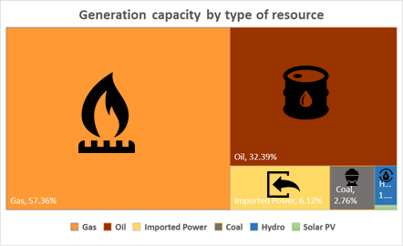
- Electrical Genration capacity of Bangadesh by type of resource used (2019) [13].

PV solar cells account for a very small percentage in generation capacity for the national supply grid in Bangladesh (0.16%) [13] but there has been a growing market for PV cells in the form of microgrids. Despite the relatively high cost of PV solar cells, it has successfully been adopted for generating electricity in rural areas. These rural PV solar systems are also referred to as microgrids (small electrical grids to supply electricity in places where the national grid cannot reach). Rural areas in Bangladesh and most other developing (or third world countries) still lack access to reliable electricity which impedes economic development and growth in these areas [19].

Moreover, the geographical location of Bangladesh gives it a distinctive advantage if PV solar cells are used, Bangladesh has roughly 300 days with an average of 7 to 10 daylight hours with an average Global Horizontal Irradiance of 5 kWh/m2 in these days [20]. Hence, among the different forms of renewable energy sources available, solar energy has the highest potential and feasibility for energy production in Bangladesh.

- Objectives
- To study the feasibility of reducing the cost of solar cells in the perspective of Bangladesh by incorporating hybrid plasmonic nanoparticles to enhance the opto-electrical performance of the thin-film solar cell.
  - Analyze the current state of the power generation in Bangladesh.
  - Analyze the state of renewable energy power generation globally and in Bangladesh.
  - Identify the current techniques used to increase solar cell performance.
  - Investigate the possibility of using plasmonic nanoparticles to enhance solar cell performance.
  - Study the feasibility of using different kinds of hybrid plasmonic metal nanostructures (e.g., metal core dielectric-shell nanoparticles) in enhancing the performance of solar cells.
  - Comparative plasmon analysis: Plasmon resonance analysis of core-shell nanostructure and homogenous nanostructures using FDTD Solutions.
  - Research methodology development: Performing optical simulations using FDTD Solutions, to design and simulate different configurations of core-shell nanostructures that are going to be used in tandem with the absorbing Si layer, to enhance the opto-electronic performance of thin-film solar cells.
- Understanding the optical properties of different types of hybrid plasmonic nanoparticle systems through thorough simulations.
- Core-shell analysis to determine optimal dielectric shell thickness, core size, core shape and placement of core-shell nanostructure embedded inside the substrate.
- Identifying optimal size of the nanoparticle when placed on top of the Si substrate for potential “sandwich” configuration applications.
- Exploring the sandwich configuration of core-shell nanostructure and homogenous nanoparticle.
- Analyzing different optical and electrical parameters of Si substrates modified with hybrid plasmonic nanoparticle systems to identify parameters important for designing the optimal configuration to enhance the opto-electronic performance of thin-film solar cells.
  - Exhaustive morphological study of the hybrid plasmonic nanoparticle systems (both embedded inside the absorbing layer as well as in “sandwich” configurations with homogenous metal nanoparticles on top of the absorbing substrate.
  - Investigating the optimal array configuration: by varying the interparticle distance (side to side between nanostructures) to find the optimum pitch size for the composite nanostructures when used in arrays.
  - Reaching conclusion with an optimal configuration to enhance the opto-electronic performance of the solar cell.

- Research Methodology
The steps or methodology can be demonstrated with a flowchart as shown in Figure 1.4.1. Extensive literature review regarding solar cell limitations were conducted and possible approaches to address these limitations were identified, as mentioned earlier. The focus was on utilizing hybrid nanostructures as they showed tremendous potential towards overcoming the aforementioned limitations [10]. To find the optimal hybrid nanostructure and optimal configuration, optical and electrical parameters were analyzed.

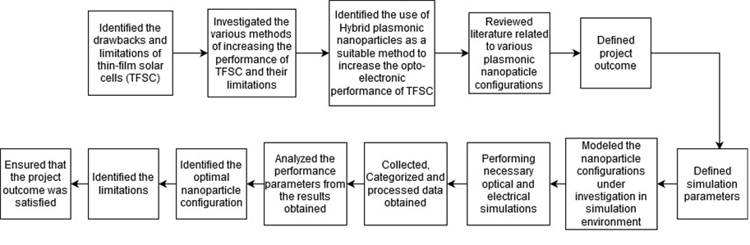
- Research Methodology.

- Organization of this Report
The thesis comprises
- Chapter 1
Discusses issues relating to the background and motivation of the thesis followed by the objectives, and structure of the general research methodology followed.
- Chapter 2
Outlines the working principle of solar cells, current thin-film solar cell technologies and delves into detailed discussions regarding plasmonic solar cells, fabrication techniques and the methodological approach employed towards determining the optimal hybrid nanoparticle system to enhance the opto-electronic performance of thin-film solar cells.
- Chapter 3
Describes the various analysis techniques and also the optical and electrical
parameters used to determine the performance of thin-film solar cells.
- Chapter 4
Presents the design rationale used to model the various hybrid plasmonic nanoparticles configurations under investigation and the parameters used to define the simulation environment to be in line with industry standard test conditions.
- Chapter 5
Highlights and discusses the results obtained from various simulations pertaining to the nanostructure configurations.
- Chapter 6
Discusses the impact of the project on society, culture and health, and address concerns regarding the environment and sustainability.
- Chapter 7
Outlines the engineering activities undertaken to address the complex engineering problems associated with the current project.
- Chapter 8
Provides a summary of the project in its entirety and includes concluding remarks.

CHAPTER 2
LITERATURE REVIEW AND METHODOLOGY

- Solar Cell Working Principle
When light is incident on the semiconductor substrate of a solar cell and reaches its p-n junction, if the incident photons have energy that is greater than the band gap energy of the semiconductor material, electron-hole pairs are generated in the depletion region. The electrons move to the n-type side of the substrate while the holes move towards the p-type side. Due to the barrier potential, these charge carriers cannot move across the junction again. When the electrical contacts of the cell are connected, electrons flow through the wire from the n-type side and recombine with the holes on the p-type side and thus the cell behaves like a DC source.

- Current Thin-film Solar Cell (TFSC) Technologies
There are two major photovoltaic solar technologies that are commercially available: traditional crystalline solar cells and thin film solar cells. This project focuses on increasing the efficiency of thin-film a-Si solar cells (a-Si is amorphous Si). Research has been conducted on various methods through which the opto-electronic performance of thin-film solar cells can be increased, namely, utilizing metal layer to create a reflective surface on the back of the solar cell, employing nano-pyramidal surface textures on the front and back of the solar cell, and using plasmonic metal nanoparticles [21-23]. The difference in refractive index between silicon and air is very high which leads to the reflection of a significant part of the incident radiation from the interface of the two mediums (silicon and air), which is otherwise known as strong Fresnel reflectivity [24-25]. To reduce this phenomenon, the use of anti-reflection coatings (ARC) on thin-film solar cells have been proposed [26]. While these ARCs improve the performance of thin-film solar cells, their fabrication is complex and costly due to the expensive equipment involved and the precise control that is required during synthesis, thereby increasing the cost of fabrication substantially [27]. Attempts have been made towards increasing the opto-electronic performance of solar cells using nanostructures like nanopillars, which reduces the Fresnel reflectivity by acting as an additional medium between air and the substrate [28]. But this method leads to an increase in surface recombination and a reduction in the amount of charge carries which ultimately contributes to less current generation [27]. Approaches towards employing surface textures like surface grating has been reported to aid in increasing the optical absorption of solar cells. However, these surface textures are usually fabricated in the micron scale (10-15 microns in thickness) which is considerably large when comparing with the thickness of thin-film solar cells and is therefore not suitable for use in 2nd generation thin-film solar cells [29]. Furthermore, surface texturing using nanoparticles with high aspect-ratio results in higher surface defects thus increasing recombination of electron-hole pairs [30].

- Plasmonic Solar Cells
Plasmonic nanoparticles in the presence of a metal-dielectric interface exhibit LSPR when excited by electromagnetic radiation whose wavelength matches the resonant wavelength of the electron density of the metal. The resonant wavelength is dependent on the dielectric medium (surrounding the nanoparticle) and also the physical parameters of the metal nanoparticle (e.g.: radius, length, height, morphology etc.). This phenomenon results in amplifying the radiation in the immediate vicinity of the nanostructure, thereby increasing the absorption of the incident radiation into the absorbing layer, enhancing its light trapping capability, generating more charge carriers and thus improving the solar cells performance. Thus, by placing a homogeneous nanostructure on top of the substrate, this phenomenon can be exploited to increase the light absorbing capability of the semiconductor substrate of a solar cell and improve its opto-electronic performance.
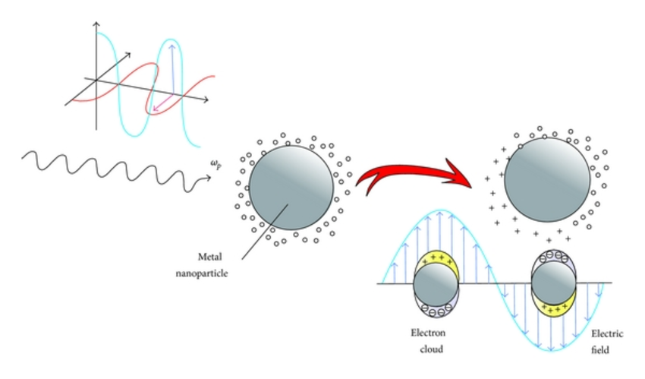
- Electirc field diagram demonstrating localised surface plasmon resonance.

- Core-Shell Nanoparticles
Similarly, metal core-dielectric shell nanostructures have been observed to increase a solar cells light absorption capability while ensuring chemical and electrical isolation due to the presence of a protective shell. This results in greater stability while providing increased performance. Furthermore, such hybrid nanostructures have also been observed to maximizing forward scattering into the substrate while minimizing backward scattering away from the substrate [31]. Thus, core-shell nanostructures can be embedded into the substrate to increase the absorber layers’ light trapping potential and result in greater charge carrier generation. Furthermore, these two configurations of nanostructures can be combined to form a “sandwich” configuration, where a homogenous nanoparticle is placed on top of the substrate, while a core-shell nanoparticle is embedded inside the absorber layer.

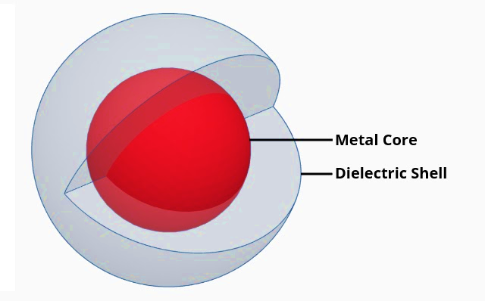
- Model of a core-shell nanoparticle comprsing a metal core enclosed in a dielectric shell.

- Fabrication Techniques
Metal nanostructures can be fabricated using lithography (ultraviolet, electron beam, scanning probe and optical NF), laser beam processing and machining. Fabrication of these hybrid nanostructures can also be done by altering the chemical structure on a molecular level to arrange them in the desired formation using methods like vapor deposition, laser tapping, colloidal aggregation and, deposition-growth on films [32]. Silica shell can be synthesized using the Stöber or sol-gel process. There are many methods to synthesize a-Si thin-films like vapor deposition techniques (physical vapor deposition, low pressure and plasma enhanced chemical vapor deposition,), vacuum evaporation deposition and atomic layer deposition [33].

- Detailed Methodology
To determine the optimal hybrid nanostructure and optimal configuration, optical and electrical parameters will be analyzed. From Figure 2.6, it can be seen that the analysis can be divided into two parts: 1) optical analysis of plasmonic thin-film solar cells and 2) electrical analysis of plasmonic thin-film solar cells. Optical analysis mainly comprises of optical properties such as plasmon resonance analysis of the hybrid nanoparticles derived from the extinction spectra (summation of absorption spectra and scattering spectra), optical absorption enhancement obtained from thin-film solar cells modified by the hybrid nanoparticles, etc. Whereas the electrical analysis comprises of short circuit current density (J_{SC}), open circuit voltage (V_{OC}) etc.
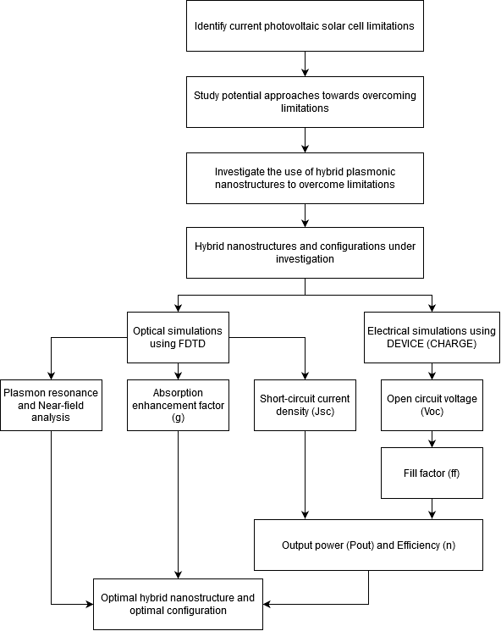
- Flow chart illustrating the various analysis performed with the end goal of determining an optimal configuration of hybrid nanostructure to aid in increasing the opto-electronic performance of thin-film solar cells.

CHAPTER 3
OPTO-ELECTRONIC PARAMETERS OF THIN-FILM SOLAR CELLS AND ANALYSIS TECHNIQUES

- Absorption Enhancement Factor (g)
To determine the enhancement in the absorption of light into the substrate as a result of using plasmonic nanoparticles, the optical absorption enhancement factor (g) is used and can be calculated by using the following formula:

This is an important optical parameter since it allows us to plot and analyze the increase in optical energy absorption due to the addition of plasmonic nanostructures when compared to the bare Si substrate solar cell, over the entire spectrum of the incident light. The optical simulations concerned with determining the optical absorption enhancement factor will be carried out using 150 frequency points (in order to compare results with the previous studies) [34]. Summing the g corresponding to each frequency point yields a discrete value that can be used to compare the overall absorption enhancement for each hybrid nanostructure configuration. This inevitably means that the sum of g for bare Si substrate will always be equal to 150 as g will be unity for each of its frequency points. Consequently, calculated values that are greater than 150, for any hybrid nanostructure configuration, will indicate an enhancement in optical energy absorption.

- Short-Circuit Current Density (J_{SC})
A greater optical absorption does not necessarily mean higher efficiency and performance of the solar cell because not all electron-hole pairs created due to the absorption of photons result in current generation, due to electron-hole pair recombination before being collected by the solar cell. Quantum efficiency is the ratio of the number of carriers (electron-hole pairs) generated and collected in the contacts to the number of photons of the incident solar radiation of any particular wavelength. Therefore, electrical parameters that are linked to quantum efficiency like short-circuit current density (J_{SC}) need to be determined in order to establish the optimal configuration more accurately [35].

- Open-Circuit Voltage (V_{OC})
The open-circuit voltage determines the maximum potential difference that a solar cell is capable of producing. Thus, the open circuit voltage (V_{OC}) should also be determined to calculate the normalized open circuit voltage (used to determine the fill factor) and output power of the solar cell. The aforementioned optical and electrical parameters (g, J_{SC} & V_{OC}) can be obtained from optical and electrical simulations using appropriate commercial grade software FDTD Solutions and DEVICE, developed by Lumerical Inc [36].

- Fill Factor (FF)
The fill factor (FF) determines the maximum output power capacity of a photovoltaic cell and as such is used to calculate the output power of a photovoltaic cell. It is the ratio of the power at maximum power point (V_{mp} * I_{mp}) to the product of short-circuit current (J_{SC}) and open circuit voltage (V_{OC}). In simple terms, it represents the squareness of the current-voltage curve as shown in Figure 3.4. The rectangular area, shown in grey, represents the output power of the solar cell [37].

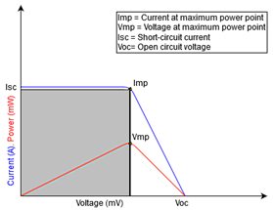
- Figure showing the I-V and P-V curves of a photovoltaic cell [37].

For our purpose, the fill factor (FF) can be determined using the following formula [38]:

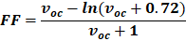

where, v_{oc} is the normalized open circuit voltage, and can be calculated using the following equation [38]:

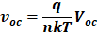

where, V_{OC} is the open circuit voltage obtained from electrical simulations, q denotes the elementary charge, η represents the ideality factor, k stands for the Boltzmann constant and T gives the temperature in Kelvin.

- Output Power (Pout) and Efficiency (η_{conv})
Finally, the output power (P_{out}) in watts and energy conversion efficiency (η_{conv}) of the solar cell can be calculated from the previously obtained parameters by using the following formulae [39]:

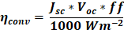

where, 1000W/m² is the standard test condition (STC) input power provided by the incident radiation.

- Extinction Cross-section Spectra Analysis
The absorption band of Si, lies approximately between 300nm and 800nm. It is observed that the highest absorption coefficient for a-Si and the peak of the solar irradiation spectrum both lie within this wavelength range [40]. Thus, determining the plasmon resonance wavelength for the nanostructures under investigation allows us to identify the particles capable of the strongest light coupling, that fall within the desired wavelength range of 300-800nm, i.e., the visible wavelength spectrum. The optical simulations for plasmon resonance analysis can provide the absorption and scattering spectra of the incident light, the sum of which gives us the extinction spectra for each hybrid nanostructure. The aforementioned spectra can then be plotted as normalized cross-section vs. wavelength. In simple terms, a normalized cross-section is the ratio of the optical cross-section to the geometrical cross-section. For a plasmonic nanostructure configuration, the wavelength at which the peak of the normalized extinction cross-section curve is observed, is the plasmon resonance wavelength. It is at this wavelength where the strongest coupling of the SPR modes in the metal NP with the incident light can be expected to occur. Plasmon resonance analysis also allows us to observe trends like red-shift and blue-shift of the extinction spectra peak, phenomena that take place when varying parameters like shell thickness or particle morphology [41-42]. The results obtained throughout the project will be cross matched with published experimental data and built upon to form coherent conclusions.

- Optical Near-field Analysis
Furthermore, optical simulations will need to be performed to observe the enhancement of electromagnetic fields in the near-field region for each metallic nanostructure once they are incorporated on or within the Si substrate at its plasmon resonance wavelength. Data from these simulations can be used to plot and generate near-field images that will allow further analysis of the field patterns and features like electromagnetic field intensity, forward-scattering of light, plasmonic coupling, etc. This will further aid in supporting the findings and cementing the conclusions with respect to the calculated optical and electrical parameters [39].

CHAPTER 4
MODELLING OF HYBRID NANOSTRUCTURE CONFIGURATIONS AND SIMULATION DETAILS

- Modelling of Hybrid Nanostructures and Configurations

Figure 4.1.1 represents the design of the core-shell nanoparticle modeled for simulation. The “core” of the core-shell nanoparticle can be modeled by using a primitive sphere available in the FDTD simulation environment library. Likewise, the “shell” can also be considered as a spherical primitive and can be used to enclose the “core”. Moreover, silver (Ag) and silica (SiO₂) material profiles, available in the software’s materials library, can be assigned to the “core” and “shell” structures respectively. Appropriate mesh orders were assigned to the “core” and “shell” entities as per guidelines provided in Lumerical FDTD documentation.

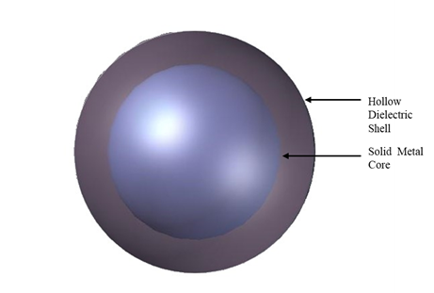
- Design of the Core-Shell (Ag (core)-SiO₂.(shell) ) particle in Lumercial FDTD.

Previous studies have shown that the optimum size of the core was reported to be 100nm (diameter) and the optimum shell thickness was 5nm while improved results were obtained when the core-shell particles were embedded 5nm below the surface of the substrate [9]. In order to find the optimal configuration of the nanostructures in “sandwich” configuration, simulations were performed by varying the diameter of the homogenous NPs, from 100nm to 200nm. Particles below 100nm were not considered since literature studied showed poor enhancement for particles below 100nm (diameter) [43]. Using the results obtained, the nanostructures were then configured into a “sandwich” complex and further simulations were performed to obtain the optimal design. A comparison was drawn between the optimal results of each configuration in order to assess their opto-electronic performance with respect to the bare silicon substrate. However, the plasmonic properties of these hybrid core-shell nanoparticles are highly morphology-dependent that is differently shaped particles show different and unique optical characteristics. Hence, to investigate the morphology dependent optical properties of these hybrid core-shell particles five hybrid core-shell nanoparticles were investigated, they were as follows: cube, cylinder, pyramid sphere and spheroid. To correlate the opto-electronic performance with use of different shapes, a uniform volume was maintained across the all the shapes considered. Then simulations were performed to find the optimum shape of the nanoparticles when embedded inside the substrate and in “sandwich” configuration. The results from these studies were then used to model solar cells with arrays of these hybrid nanoparticles to find the optimal pitch size for these composite nanostructures where pitch size indicates the interparticle side-to-side distance between two adjacent nanostructures. The results of these simulations would enable us to ultimately determine the most optimal hybrid nanostructure configuration for implementation, thus fulfilling the overarching objective of the current project.

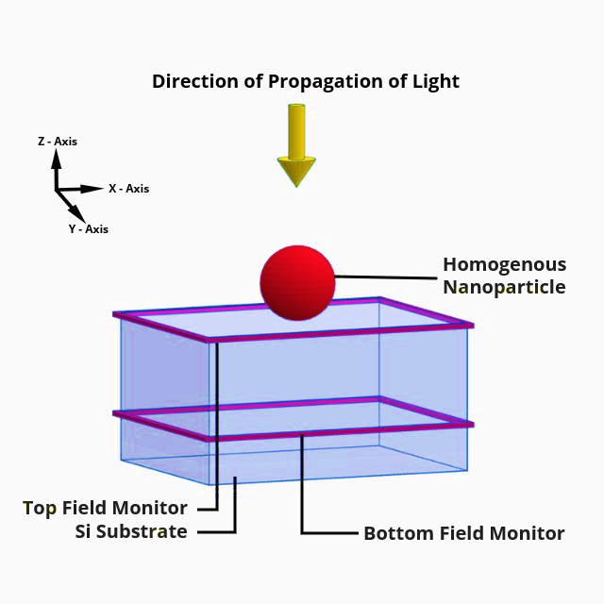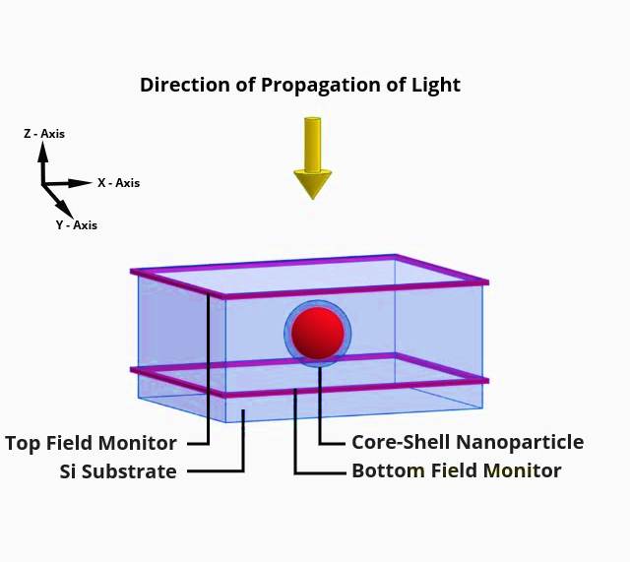 (a) (b)
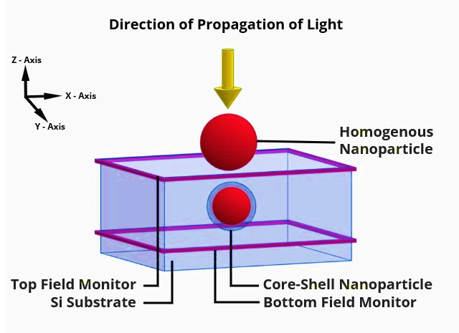
(c)
- Diagrams illustrating the modeled a) Homogeneous nanoparticle configuration, b) Embedded Core-Shell nanoparticle configuration and, c) Homogenous and Core-Shell nanoparticle in “Sandwich” configuration.

Figure 4.1.2 shows how the spherical homogenous, embedded core-shell and “Sandwich” nanoparticle configuration particles under investigation, were be modeled in FDTD to obtain the performance parameters in order to deduce the optimal configuration most capable of increasing the opto-electronic performance of thin-film solar cells. Figure 4.1.2a illustrates a single homogenous nanoparticle placed on the surface of the solar cell while Figure 4.1.2b shows a single core-shell nanoparticle embedded inside the absorber layer. Figure 4.1.2c represents the “Sandwich” configuration achieved due to the placement of a homogenous nanoparticle on top the substrate and a core-shell nanoparticle embedded inside the Si absorber layer.

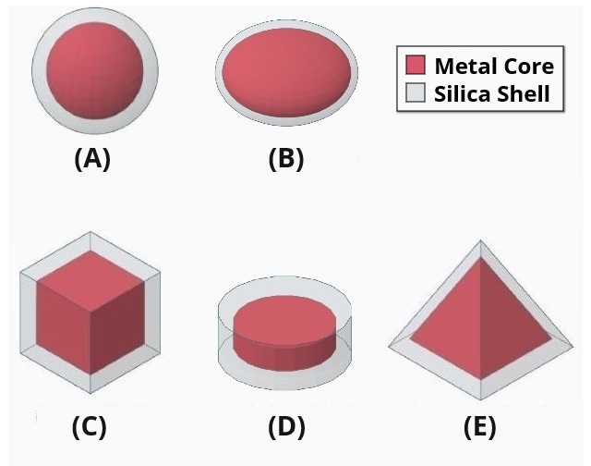
- Diagrams illustrating the modeled a) Representation of different core-shell nanoparticles: A) Spherical metal core – hollow spherical dielectric shell; B) Spheroidal metal core – hollow spheroidal dielectric shell; C) Cubical metal core – hollow cubical dielectric shell; D) Cylindrical metal core – hollow cylindrical dielectric shell; E) Pyramidal metal core – hollow pyramidal dielectric shell.
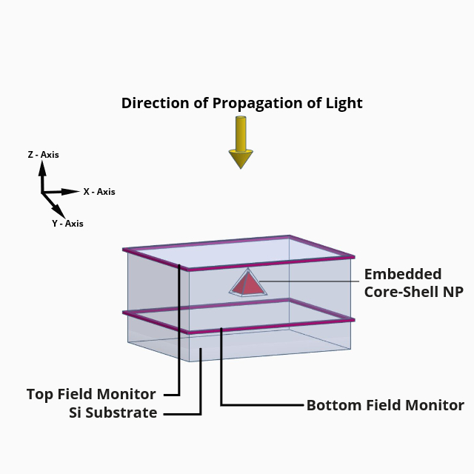
(a)
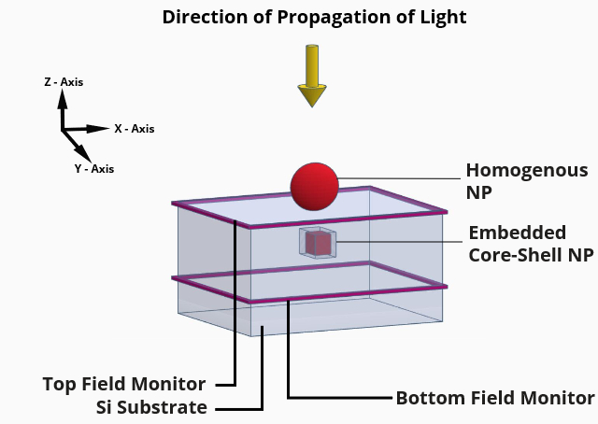
(b)
- Diagrams depicting a) the embedded core-shell nanoparticle configuration utilized to determine the optimal shape for embedding core-shell nanostructures within the absorber layer, and b) configuration of homogenous nanoparticle and differently shaped embedded core-shell nanostructure to determine the optimal “sandwich” configuration.

Figure 4.1.3 shows the various shapes of core-shell nanoparticles under investigation while Figure 4.1.4(a) illustrates how the embedded nanostructure configuration was modeled in FDTD in order to determine which shape of embedded core-shell nanoparticle produces significantly improved opto-electronic performance for thin-film solar cells. Table 4.1 outlines the physical parameters of each shape of the core-shell nanoparticles, which were used to design each core-shell nanoparticle such that the volume of the core was kept constant, as previously mentioned. Figure 4.1.4(b) shows the “Sandwich” configuration of a homogenous nanoparticle on top the substrate and core-shell nanoparticle of optimal shape (cube-shell nanoparticle) embedded inside the Si absorber layer.

- Physical parameters of metal-core silica-shell nanoparticles.

Shapes | Core Dimensions | Shell thickness | Volume of core
Cube | Length = 80.6 nm | 2nm
Cylinder | Radius = 60 nm, Height = 46.296 nm | 2nm
Pyramid | Square base length = 130 nm, Height = 93 nm | 5nm
Sphere | Radius = 50 nm | 5nm
Spheroid | Radius (x) = Radius (y) = 63 nm, Radius (z) = 31 nm | 2nm

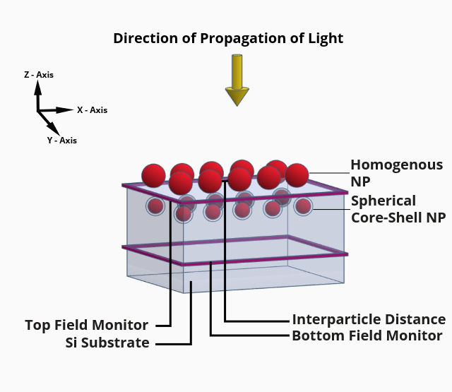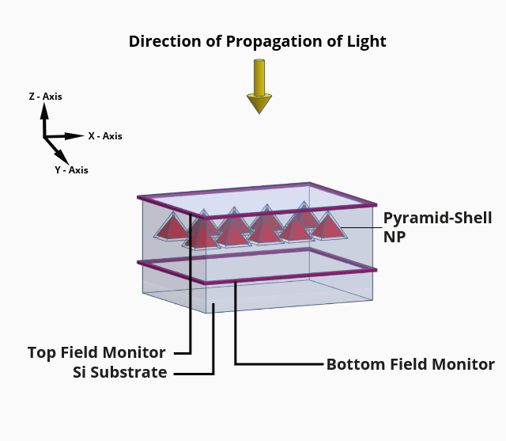
(a) (b)
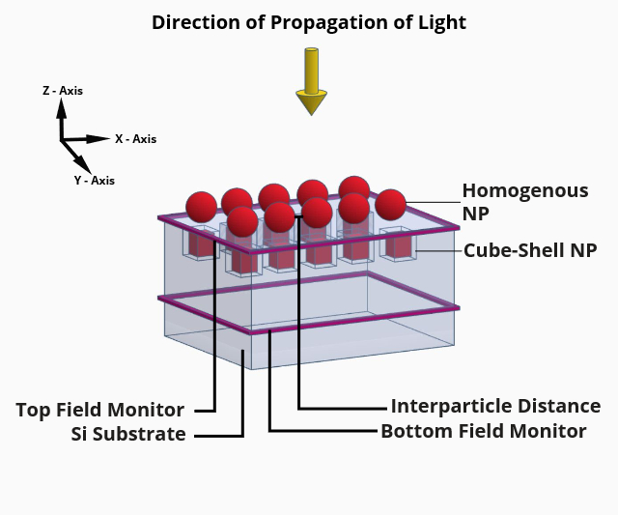
(c)
- Diagrams illustrating the modeled a) Arrays of sphecial “sandwich” nanoparticle configuration, b) Arrays of embedded pyramidal Core-Shell nanoparticle configuration and, c) Arrays of “sandwich” naoparticle configuration comprising spherical homogenous NP on top of Si substrate and Core-Shell NP embedded inside the substrate.

Figure 4.1.5 shows how arrays of these nanoparticles were incorporated with thin film solar cells and subsequently modelled in the software to determine the optimal pitch size for optimum opto-electronic performance. Figure 4.1.5(a) shows how the arrays of homogenous NP on top and spherical core-shell NP embedded inside the absorber layer in “Sandwich” configuration was modeled. Figure 4.1.5(b) shows how arrays of pyramidal core-shell hybrid nanoparticles were embedded inside the absorbing Si layer and Figure 4.1.5(c) shows how arrays of the “Sandwich” nanostructure configuration comprising homogenous nanoparticles on top of the substrate and embedded cubical core-shell nanoparticles were modelled in the simulation environment.

- Simulation Parameters
The exact placement of the nanoparticles and the monitors used, as well as standard test conditions and other simulation parameters have been defined in Table 4.2. The bottom field monitor is placed 500nm beneath the surface of the substrate since the electromagnetic fields are more stable in this region than near the surface of the substrate.

- Parameters used for all simulations performed using the Lumerical FDTD simulation environment.

Simulation Parameter | Value
Homogeneous nanoparticle position | On top of the surface of the substrate
Core-shell nanoparticle position | 5nm below the surface of the substrate
Top field monitor position | On the surface of the substrate
Bottom field monitor position | 500nm below the surface of the substrate
Temperature | 300K
Solar Irradiance spectrum | AM 1.5G
Solar Irradiance power | 1000W/m²
Wavelength range | 300nm-800nm
Mesh type | Conformal mesh
Mesh size | 2nm
Frequency points | 150
Boundary condition | PML (for single unit) & antisymmetric-symmetric (for arrays)

- Standard Testing Conditions and AM 1.5G Solar Spectral Irradiance
Industry standard test conditions (STC) like temperature (300K) and air mass coefficient (AM 1.5G) were maintained for all simulations [44]. The air mass coefficient (AM) is a ratio of the optical path length through the earth’s atmosphere (at a certain zenith angle) to that of the path length at zenith. The zenith refers to the normal to the earth’s surface as shown in Figure 4.3. As solar radiation enters the atmosphere and travels towards the surface, its energy is attenuated due to absorption and scattering. Various chemical molecules present in the atmosphere absorb the energy at different wavelengths from the solar spectrum. The more atmospheric thickness that light has to travel through, the greater the attenuation. AM1.5G or ASTM G-173 refers to the spectral irradiance profile for light that has traveled through a 1.5 atmosphere or air mass thickness at a zenith angle of 48.2°. This spectral irradiance distribution was established by the American Society for Testing and Materials (ASTM) for the standardized testing and rating of terrestrial photovoltaic cells across the solar industry worldwide [45]. Using AM1.5G solar irradiance for simulations conducted throughout the course of this project ensures compliance with industry standards and also allows us to get a step closer to obtaining “realistic” results.
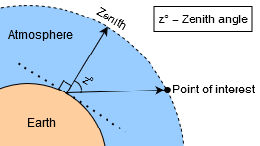
- An illustration of the zenith and zenith angle with respect to the earth’s surface and point of interest.

- Data Collection and Processing
In order to measure the net amount of light being absorbed as a function of wavelength, the optical simulations for each configuration can be set up in FDTD as shown in Figure 4.1.2 through 4.1.5. Field and power monitors are used to record data regarding electromagnetic fields and power in the frequency domain. The data sets generated by these monitors can be used to calculate the amount of light passing through them as a function of frequency or wavelength. Using a set of these two-dimensional z-normal monitors, it is possible to calculate the amount of light being absorbed by the substrate. This can be done by placing one monitor on the surface of the substrate (Top Field and Power Monitor) and another well inside the substrate (Bottom Field and Power Monitor). The transmission data from the bottom field monitor can then be subtracted from transmission data of the top field monitor, thus providing the net transmission of light into the substrate, i.e., the amount of light absorbed by the Si absorbing layer as a function of wavelength. Through this method, the absorption of light for bare Si substrate and the Si substrate modified with each hybrid nanostructure configuration can be determined and the absorption enhancement factor (g) can be calculated using the aforementioned formula. FDTD solutions provide a functional analysis block named solar generation which was utilized in the simulations to calculate the electron-hole pair generation rate (from the photon absorption data) when the semiconductor substrate is illuminated by unpolarized solar radiation with AM1.5G spectral intensity. The generation rate obtained from this analysis block was then exported to DEVICE for electrical simulations. The optical data obtained through FDTD simulations were also extracted to a MATLAB compatible file so that the post processing of data could be handled by the advanced functions and graphical features provided in MATLAB.

CHAPTER 5
RESULTS AND DISCUSSION

- Results for Spherical Homogenous NP on Top, Embedded Core-Shell NP, and Sandwich Configuration of Homogenous NP on Top and Embedded Core-Shell NP in “Sandwich” Configuration

- Extinction Cross-Section Spectra Analysis
Figure 5.1.1(a) shows the extinction spectra plots for the homogenous nanoparticles (Ag 100nm and Ag 160nm), and core-shell nanoparticle (Ag-SiO₂) used for the various nanostructure configurations under investigation. As mentioned earlier, an extinction spectra peak corresponds to the wavelength at which the sum of the absorption and scattering spectra is the highest, thus indicating the presence of an SPR mode where the strongest light coupling occurs. Thus, it is evident that resonant wavelength for the 160nm Ag nanoparticle is at 377nm. Similarly, the resonant wavelength for the 100nm Ag nanoparticle is at 395nm. However, when the same 100nm Ag nanoparticle is used as the “core” of the core-shell nanostructure, the extinction peak becomes more prominent and the resonant wavelength of the core-shell nanoparticle red shifts to 418nm. It is to be noted that the resonant wavelength for all three nanoparticles is within the wavelength range (300-800nm) pertaining to our application (absorption band of the silicon substrate solar cell). Therefore, the optical enhancements produced as a result of employing these nanoparticles can be well utilized by the absorbing layer and provide the opportunity for increasing the opto-electronic performance of thin-film solar cells. The plots in Figure 5.1.1(b), show the absorption enhancement obtained over the wavelength range of 300nm-800nm due to the Ag nanostructures used in tandem with the bare silicon substrate. The values of g calculated from the plots outline that the use of “sandwich” configuration with the silicon substrate yielded the highest absorption enhancement factor in the wavelength range of 300nm to 800nm when compared with the use of just the homogeneous Ag NP on top of the substrate and the use of just core-shell (Ag-SiO₂) NP embedded inside the Silicon substrate.
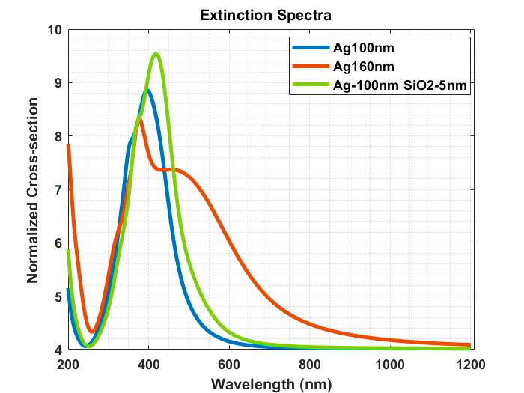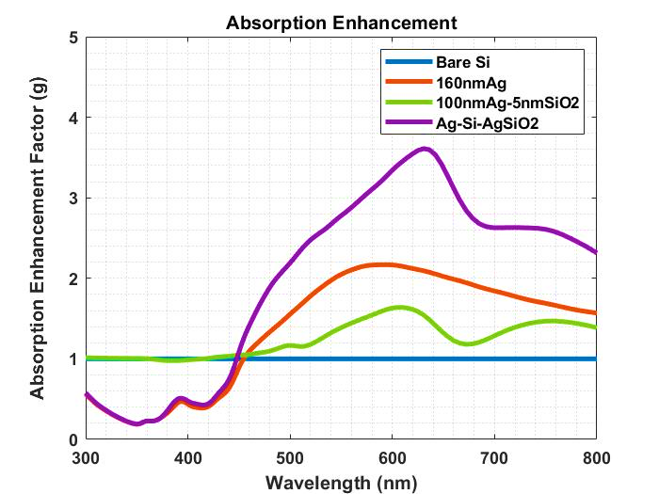
- Extinction spectra for 100nm Ag NP, 160nm Ag NP and a Core-Shell (Ag-SiO₂) nanoparticle with a 100nm diameter core and shell thickness of 5nm (b) Optical absorption enhancement factor “g” for bare silicon, 160nm Ag NP, core-shell NP (Ag-SiO₂) with 100nm diameter core and 5nm shell thickness, and “sandwich” (Ag-Si-AgSiO₂) nanostructure comprising 160nm Ag NP on top of the silicon substrate with the aforementioned Core-Shell (Ag-SiO₂) NP embedded inside the Silicon substrate.

- Determining the Optimal Diameter of Homogenous NP to be Placed on Top of the Absorber Layer
From the results in Table 5.1.2, it can be observed that both optical absorption enhancement factor (g) and short circuit current density (J_{SC}) increase with the increase in diameter of the particle and the highest g and J_{SC} was obtained for the AgNP particle with diameter 160nm. For particles larger than 160nm a decrease in both g and J_{SC} was observed. Hence, among the different diameters considered in Table 5.1.2, the values for 160nm Ag NP on the silicon substrate showed improved optical absorption enhancement (g = 163.15884) and short circuit current density (J_{SC} = 9.13718 A/m²).

- Short-circuit current (Jsc) and absorption enhancement factor (g) results for homogenous nanoparticle configuration (Ag) on top of the silicon substrate.

Diameter of Homogenous Ag NP | Absorption Enhancement Factor (g) | Short Circuit Current Density (J_{SC}) A/m²
Bare Silicon | 150 | 6.8371
100nm | 146.806 | 7.6337
110nm | 153.401 | 8.3151
120nm | 155.596 | 8.6215
140nm | 161.058 | 8.7482
150nm | 161.553 | 8.8049
160nm | 163.158 | 9.1371
180nm | 157.349 | 8.0935
200nm | 149.476 | 7.5484

- Optical Absorption Enhancement and Short-Circuit Current Density for Varying Diameters of Homogenous NP Placed on Top of the Absorber Layer in “Sandwich” Configuration with Embedded Core-Shell NP
Table 3 represents the optical absorption enhancement factor (g) and short circuit current density (J_{SC}) results of the combination of homogenous and core-shell nanoparticles in “sandwich” configuration. As a result of varying the homogenous nanoparticles diameter, it is evident that g and J_{SC} increases for increasing values of diameter and peaks at 160nm diameter (g = 213.4540; J_{SC} = 9.2057 A/m²). This signifies a substantial increase in both optical absorption enhancement and short circuit current generation when compared to a bare silicon substrate (g = 150; J_{SC} = 6.83715 A/m²). However, from 160-250nm diameter, both g and J_{SC} decreases. This trend is similar to that observed in Table 5.1.2. It is important to note that the highest J_{SC} value obtained from the “sandwich” configuration simulation is only slightly higher than that obtained from homogenous nanoparticle configuration simulations. This is due to the fact that the incorporation of the core-shell nanoparticle in the absorber layer effectively reduces the total volume of the silicon substrate available for charge carrier generation, which in turn reduces the maximum possible short-circuit current density that can be obtained. This effect is further amplified as the simulations are performed using PML boundary conditions and is also reflected in the results in Table 5.1.3.

- Short-circuit current (J_{SC}) and optical absorption enhancement factor (g) results for homogenous NP (on top of the substrate) and core-shell NP (embedded inside the substrate) in “sandwich” configuration (Ag-Si-AgSiO₂).

Diameter of Homogenous Ag NP with constant diameter of Core-Shell NP (Ag “core” = 100nm; SiO₂ “shell thickness” = 5nm) | Absorption Enhancement Factor (g) | Short Circuit Current Density (J_{SC}) A/m²
Bare Silicon | 150 | 6.8371
50nm | 169.932 | 6.7942
60nm | 170.137 | 6.9014
70nm | 171.174 | 7.0737
80nm | 173.036 | 7.2743
90nm | 177.269 | 7.5849
100nm | 180.809 | 7.7402
110nm | 190.500 | 8.2916
120nm | 195.423 | 8.4794
130nm | 200.930 | 8.5780
140nm | 206.975 | 8.7550
150nm | 209.655 | 8.7111
160nm | 213.454 | 9.3205
170nm | 210.058 | 8.4543
180nm | 205.464 | 8.1293
190nm | 201.837 | 7.9633
200nm | 194.173 | 7.6164
250nm | 149.681 | 6.3156

- Opto-Electronic Performance Parameter Comparison Between Bare Si Absorber Layer, and Absorber Layer Modified with Homogenous NP, Embedded Core-Shell NP, and “Sandwich” Configuration of Homogenous NP and Embedded Core-Shell NP
Table 5.1.4 shows the comparison between all three nanostructure configurations, namely homogenous nanoparticle (Ag), embedded core-shell nanoparticle (Ag-SiO₂), and “sandwich” configuration (Ag-Si-AgSiO₂). It is evident that the “sandwich” configuration (160nm homogenous Ag nanoparticle on the surface of the substrate and embedded Ag-SiO₂ core-shell nanoparticle inside the absorber layer) resulted in the highest optical absorption enhancement (g), short-circuit current density (J_{SC}), open circuit voltage (V_{OC}), power, fill factor (FF) and efficiency (η) among the three different nanostructures studied. The output power for the homogenous nanoparticle configuration is more than that of the embedded core-shell nanoparticle configuration, since the short circuit current density of the embedded core-shell nanoparticle configuration is less due to the aforementioned reasons provided in this report. Furthermore, the value of power is considerably low for all configurations since the area of the simulation region was used to calculate the output power, which was in the nanometer scale.

- Optical absorption enhancement, short circuit current density (J_{SC}), open circuit voltage (V_{OC}), output power, fill factor (FF) and efficiency (η) for bare silicon substrate, homogenous nanoparticle configuration (Ag), embedded core-shell nanoparticle configuration (Ag-SiO₂), and “Sandwich” configuration (Ag-Si-AgSiO₂).

Configuration | Absorption Enhancement Factor (g) | Short-Circuit Current Density (J_{SC}) A/m² | Open circuit Voltage (V_{OC})  V | Fill Factor (FF) | Power (x10⁻⁹) mW | Efficiency (η) %
Bare Si | 150.00 | 6.837 | 0.3954 | 0.7684 | 1.629 | 2.09
Ag (160nm) | 163.16 | 9.137 | 0.3962 | 0.7687 | 2.182 | 2.78
Ag-SiO₂ (100nm Ag core; 5nm SiO₂ shell) | 172.76 | 6.913 | 0.3962 | 0.7687 | 1.651 | 2.11
Sandwich (Ag-Si-AgSiO₂) | 213.45 | 9.321 | 0.3980 | 0.7695 | 2.238 | 2.85

- Optical Near-field Enhancement Analysis
Figure 5.1.5 shows the optical near-field enhancement images for the embedded Ag-SiO₂ configuration and Ag-Si-AgSiO₂ “sandwich” configuration, illustrating the intensity of the electromagnetic field in the immediate region around the nanostructures. It is evident that the field intensity is considerably higher for the “sandwich” configuration due to the coupling of light between the homogenous nanoparticle on the substrate and the core-shell nanoparticle inside the substrate. Considering the logarithmic scale used to plot the image, the red areas shown denote a 316-fold near-field enhancement and further reinforces the results obtained in Table 5.1.4.

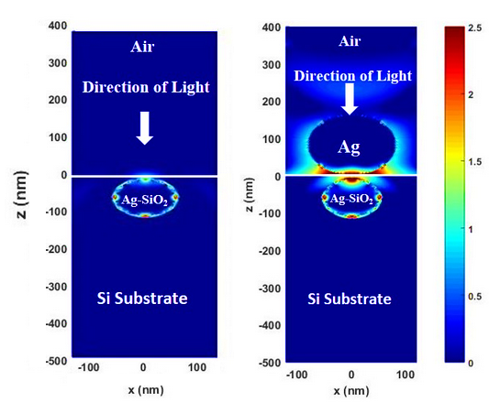
- Optical near-field enhancement images illustrating the electromagnetic field patterns for (a) Embedded core-shell nanoparticle configuration, and (b) Homogenous and core-shell nanoparticle in “Sandwich” configuration.
- Results for Differently Shaped Core-Shell NPs with Varying Shell Thickness
- Extinction Cross-Section Spectra Analysis
Figure 5.2.1 portrays the extinction spectra graphs of different shaped core-shell particles (spherical, cylindrical, pyramidal, spheroidal, and cubical shaped particles) comprising metal (Ag) core and dielectric (SiO₂) shell and outlines the relation between the plasmon resonance wavelength and shell thickness of these composite particles. The plots in Figure 5.2.1 (A) were used to find the plasmon resonance wavelength of these different shaped composite particles. It is observed from these plots that the plasmon resonance of the nanocomposite particles lies between 400nm and 700nm which is the region where silicon based photovoltaic cells operate optimally. Furthermore, it is observed that the normalized extinction cross section (y-axis) of these hybrid particles are many times greater than the geometric cross-section with the highest being observed by the spherical core-shell particle. The result is as predicted due to the due to the strong LSPR modes created in these NPs as a result of the incoming incident radiation in the visible wavelength range. The extinction cross section peaks outline the resonance wavelength, where the strongest coupling took place between these core-shell particles and the incident radiation, these results conform to the results obtained by Noguez et al who conducted comprehensive studies on morphology dependent LSPR properties of metal nanoparticles [41-42]. Figure 5.2.1 (B) draws a relation between outer layer shell (silica) thickness and the plasmon resonance wavelength. It is observed that with the increase in thickness of the silica shell, the plasmon resonance wavelength of the spherical core (Ag) gets red-shifted (move towards longer wavelengths). The same phenomenon was observed for the other shapes of Core (Ag)-Shell (SiO₂) particles.

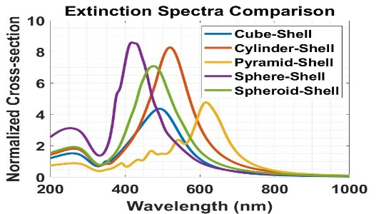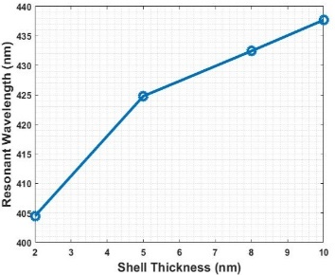
(A) (B)
- (A) Extinction spectra for Sphere-shaped Core-shell NP, Cylinder-shaped Core-shell NP, Pyramid-shaped Core-shell NP, Spheroid-shaped Core-shell NP and, Cube-shaped Core-shell NP; (B) Plot showing the relation between the plasmon resonance wavelength of a sphere-shaped Ag core-SiO₂ shell NP and its shell thickness.

- Determining the optimal shell thickness for differently shaped core-shell hybrid nanoparticles.
As mentioned before, the optical properties of hybrid core-shell particles vary with respect to a change in their morphology, that is both the shape of these particles as well as particle parameters such as shell thickness influence and shape the optical behavior of these hybrid structures. Hence, simulations were carried out to determine the optimal shell thickness for core-shell shape considered. The performance parameters, absorption enhancement factor (g) and short circuit current density (J_{SC,} A/m²) were calculated for a Silicon substrate modified with these hybrid core-shell nanoparticles and the results obtained were used to evaluate the optimal dielectric (SiO₂) shell thickness of these core-shell nanoparticles. The results of the simulations are provided in Table 5.2.2, the highest optical absorption enhancement factor was observed for cylindrical shaped core-shell particle with a 10nm shell thickness and highest J_{SC} was obtained for pyramidal core-shell particles with a 5nm thick shell. The results in table show that for some core-shell particles, highest value obtained for optical absorption enhancement and short circuit current density do not coincide. This indicates that even though more light was absorbed by the semiconductor substrate, it did not result in creation of higher number of electron-hole pairs that contribute to current generation. Highest J_{SC} for cube shaped core-shell NP was observed for 2nm shell thickness however, highest g was observed for 10nm shell thickness. This lower current generation may be due to a higher recombination rate when 10nm thick shell was used. In selection of the optimal shell thickness short circuit current density was given precedence over optical absorption enhancement as J_{SC} is directly related to the quantum efficiency of the cell. For cubical, cylindrical and spheroidal core-shell particles highest J_{SC} was observed for shell thickness of 2nm and for Pyramidal and spherical core-shell particle highest J_{SC} was obtained for shell thickness of 5nm.

- Optical Absorption Enhancement and Short-Circuit current Density (J_{sc}) in a/m² For Core-Shell Particles having Varying Shell Thickness.

NP | 2nm shell |  | 5nm shell |  | 8nm shell |  | 10nm shell
 | g | J_{sc} | g | J_{sc} | g | J_{sc} | g | J_{sc}
Cube | 288 | 2.68 | 287 | 2.55 | 293 | 2.67 | 303 | 2.54
Cylinder | 305 | 2.44 | 302 | 2.33 | 309 | 2.30 | 324 | 2.25
Pyramid | 255 | 2.79 | 254 | 3.03 | 252 | 2.26 | 251 | 2.03
Sphere | 182 | 1.99 | 175 | 2.01 | 172 | 1.89 | 171 | 1.85
Spheroid | 192 | 1.97 | 192 | 1.83 | 189 | 1.50 | 189 | 1.77

- Results for Differently Shaped Core-Shell NPs Embedded Within the Absorber Layer

- Opto-Electronic Performance Parameter Comparison for Differently Shaped Core-Shell NPs Embedded Inside the Absorbing Si Substrate.
Table 5.3.1 records different performance parameters obtained for core (Ag)-shell (silica) particles embedded inside the silicon substrate using their optimal shell thickness obtained. Pyramidal core-shell particles showed improved results in terms of short circuit current density (J_{SC}), fill factor, output power and efficiency. Higher optical absorption enhancement was observed for cylindrical core-shell particles but this did not translate to higher J_{SC}, indicating a possibility of higher surface recombination for cylindrical core-shell particles another possibility maybe that photon absorbed do not have the required energy to promote the electron from the valence band to conduction band thereby creating electron-hole pairs which are responsible for current generation but still contribute to optical absorption enhancement factor, g.

- Optical Absorption Enhancement, Short Circuit Current Density (J_{sc}), Open Circuit Voltage (V_{OC}) fill factor, output power and efficiency for core (Ag) - dielectric-shell (SiO₂) NPs of different shapes, embedded inside the silicon absorbing substrate using their respective optimum shell thickness.

Particle | g | J_{SC}(A/m²) | V_{OC}(V) | FF | Power(W/m²) | Efficiency (%)
Cube-Shell(2nm) | 288.119 | 2.6819 | 0.3946 | 0.768 | 0.81 | 0.0813
Cylinder-Shell(2nm) | 304.665 | 2.7395 | 0.3946 | 0.768 | 0.74 | 0.0739
Pyramid-Shell(5nm) | 253.644 | 3.0352 | 0.3948 | 0.7681 | 0.92 | 0.0921
Sphere-Shell(5nm) | 175.156 | 2.9438 | 0.3949 | 0.7681 | 0.89 | 0.0893
Spheroid-Shell(2nm) | 192.964 | 2.8842 | 0.3948 | 0.7681 | 0.87 | 0.0875
Bare Silicon (no NPs) | 150 | 2.6950 | 0.3947 | 0.768 | 0.82 | 0.0817

- Optical Near-field Enhancement Analysis.
Figure 5.3.2 shows the optical near-field enhancement images of different shaped core-shell particles in the x-z plane (where x is represented using the x-axis and z is represented using the y-axis). The respective resonance wavelength of the core-shell particles considered (for sphere core-shell: λ_{exc} = 416nm; cylinder core-shell: λ_{exc} = 520nm; spheroid core-shell: λ_{exc} = 477nm, cube core-shell: λ_{exc} = 493nm; and pyramid core-shell: λ_{exc} = 616nm), were used in their own respective simulation to obtain the near-field enhancement image highlighting the EM field intensity in the immediate vicinity of the NPs and the absorbing substrate during maximum light coupling condition (i.e., at resonance wavelength). The warmer regions (red regions) represent highest enhancement of the electrical fields (or the highest light intensity) in the order of ten times enhancement as the scale is logarithmic. The different performance parameters simulated showed that pyramidal core-shell NPs obtained the highest results. The near-field enhancement image given in Figure 5.3.2 (E) further validates the previous conclusion. It is observed from Figure 5.3.2 (E) that for pyramidal NP, the EM filed intensity is highly concentrated on the top portion of the pyramid, facing the Si substrate and is indicated by the dark red region. Whereas significant back scattering was observed for cylindrical and cubical core-shell NPs (Figure 5.3.2 B and D respectively) For spherical NP (Figure 5.3.2 (A)) high EM intensity was observed near the top of the substrate with moderate concentration around the circumference of the hybrid NP. Spheroidal core-shell NP (Figure 5.3.2 (C)) showed similar enhancement concentration to that of spherical core-shell NP. That is, greatest EM field intensity was observed at the top of the substrate, at a scope and range larger than that of spherical core-shell NP however, there was no observable EM field distribution around the circumference of the spheroidal core-shell NP.

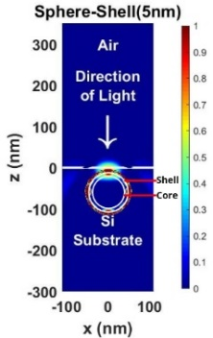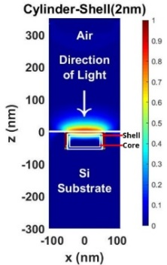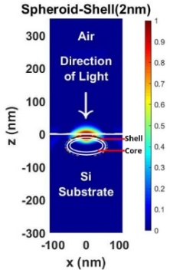
(A) (B) (C)
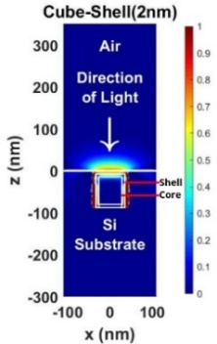 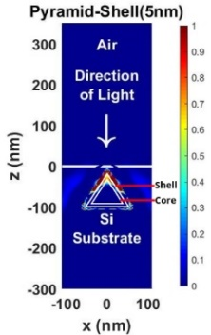
(D) (E)
- Optical enhancement image along the x-z plane for (A) Sphere-shaped core-shell NP, (B) Cylinder-shaped core-shell NP, (C) Spheroid-shaped core-shell NP, (D) Cube-shaped core-shell NP, and (E) Pyramid-shaped core-shell NP embedded within the absorbing silicon substrate.

- Results for “Sandwich” Configuration of Homogenous Nanoparticle on Top and Differently Shaped Core-Shell NPs Embedded Within The Absorber Layer

- Opto-Electronic Performance Parameters Comparison for Different ‘Sandwich’ Configurations consisting of Homogenous NP on top and core-shell (cubical, cylindrical, pyramidal, spherical, and spheroidal) NP embedded inside the Si substrate.
Table 5.4.1 shows the values of different performance parameters obtained for the hybrid core-shell nanostructure when used in a “sandwich” configuration comprising a homogenous 160nm (diameter) silver (Ag) NP placed on top of the substrate used in tandem with differently shaped core(Ag)-shell(SiO₂) NPs (using their respective optimal shell thickness obtained) embedded inside the absorbing Si layer. The diameter of the homogenous particle placed on top of the substrate (obtained from Table 5.1.2) was kept constant throughout all the different “sandwich” configurations considered. From Table 5.4.1, it can be noted that highest result for short circuit density, open circuit voltage, fill factor, power and efficiency was obtained for the “sandwich” configuration utilizing the cube shaped core-shell nanoparticles. This result can be credited to more effective coupling (when compared to other “sandwich” configurations) between the top homogenous NP and the cube-shaped embedded core-shell NP leading to the creation of more electron-hole pairs that contribute to current generation. The simulation results outlined for these nanostructure configurations were obtained by simulating only a small portion of the solar cell resulting in relatively low values of short circuit current density, output power and efficiency.

- Optical Absorption Enhancement, Short Circuit Current Density (J_{sc}), Open Circuit Voltage (V_{OC}), fill factor, output power and efficiency for Sandwich configuration of particles consisting of homogeneous AgNP on top of the substrate and core-shell NPs embedded within the Si substrate.

AgNP(160nm) with | g | J_{SC}(A/m²) | V_{OC}(V) | FF | Power(W/m²) | Efficiency (%)
Cube-Shell(2nm) | 254.421 | 6.6902 | 0.3962 | 0.7686 | 2.04 | 0.20
Cylinder-Shell(2nm) | 254.493 | 5.8287 | 0.3961 | 0.7686 | 1.77 | 0.18
Pyramid-Shell(5nm) | 243.676 | 6.3471 | 0.3958 | 0.7685 | 1.93 | 0.19
Sphere-Shell(5nm) | 246.349 | 5.0821 | 0.3957 | 0.7684 | 1.54 | 0.15
Spheroid-Shell(2nm) | 249.099 | 4.5233 | 0.3954 | 0.7683 | 1.37 | 0.14
Bare Silicon (no NPs) | 150 | 2.6950 | 0.3947 | 0.7686 | 0.82 | 0.08

- Optical Near-field Enhancement Analysis
Figure 5.4.2 shows the optical near-field enhancement image for a “sandwich” configuration comprising a 160nm (diameter)homogenous Ag NP placed on top of the substrate and an embedded cube-shaped core(Ag)-shell(SiO₂) inside the absorbing Si substrate. The enhanced near-field image in the x-z plane given in Figure 5.4.2 was obtained by using the resonant wavelength (λ_{exc} = 493nm) of the cube-shaped core-shell NP in the simulations. The enhanced image shows extremely high red regions indicating an enhancement of 10 times (as the scale is logarithmic). This indicates very strong plasmon coupling between the homogenous NP on top, the Si substrate and the embedded cube-shaped core-shell NP. A comparison between Figure 5.4.2 and Figure 5.3.2, highlights that the back scattering of light in observed in cube-shaped core-shell particle aids in stronger plasmon coupling between the homogeneous NP on top, the Si substrate and the core-shell particle itself. Furthermore, the particles in “sandwich” configuration in general led to stronger plasmonic in and around the absorbing Si substrate when compared to using just the different shaped embedded core-shell particles as is evident from the results depicted in Tables 5.3.1 & 5.4.1.
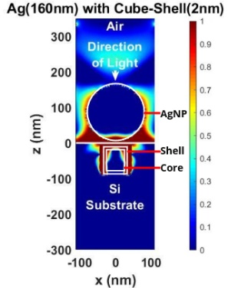
- Optical enhancement image in the x-z plane for a sandwich configuration consisting of an 160nm AgNP placed on top of the silicon substrate and a cube-shaped core-shell NP embedded within the silicon substrate.

- Results for Large Scale Array Implementation of “Sandwich” Configuration of Homogenous NP on Top and Embedded Spherical Core-Shell NP

- Optical Absorption Enhancement and Short-Circuit Current Density for Varying Pitch Sizes of Homogenous NP and Embedded Spherical Core-Shell NP in “Sandwich” Configuration

- 2D schematic showing how the pitch or interparticle distance between nanostructures in an array was measured.

Table 5.5.1 shows the absorption enhancement factor (g) and short-circuit current density values for the “Sandwich” configuration of Homogenous NP (placed on top of the absorber layer) and spherical core-shell NP (embedded well within the absorber layer), obtained when the pitch or interparticle distance between nanostructures in the array was varied from 5nm to 400nm. As mentioned previously, the pitch was measured to be the distance from the side of one nanostructure to the side of the next adjacent nanostructure. The optical absorption enhancement factor (g) was observed to increase for increasing pitch size from 5nm (g = 138.5469), reaching a maximum value at 80nm (g = 388.0258). However, the g values decrease from 80nm to 400nm (g = 220.7681), indicating reduced light trapping for larger pitch sizes. However, the short-circuit current (J_{SC}) at this pitch size was not the highest attained, since not all photons absorbed results in charge carrier generation, as discussed earlier. Nevertheless, the values obtained for short-circuit current density also followed a trend similar to the absorption enhancement factor (as the pitch size increased, the g and J_{SC} values initially increased, reached a peak value, and then decreased.). However, the highest J_{SC} was observed for a 200nm pitch size. Since the short-circuit current density is performance parameter linked to quantum efficiency, it can be concluded that a pitch size of 200nm is optimal for a “Sandwich” configuration of homogenous NP placed on top of the substrate and spherical core-shell NP embedded inside the absorber layer.

- Optical absorption enhancement and short circuit current density (J_{SC}) for varying pitch sizes of “Sandwich” configuration of Homogenous Spherical Silver NP and Embedded Spherical Silver-Silica Core-Shell NP, in array.

Pitch (side to side) (nm) for “Sandwich” Configuration of Homogenous NP on Top and Embedded Spherical Core-Shell NP | Absorption Enhancement Factor (g) | Short-Circuit Current Density (J_{SC}) A/m²
Bare | 150.000 | 61.7538
5 | 138.547 | 41.9263
10 | 175.101 | 42.6641
20 | 258.701 | 62.7695
40 | 330.131 | 81.0771
50 | 350.179 | 86.1495
60 | 365.666 | 90.0097
80 | 388.026 | 94.8123
100 | 384.680 | 101.453
150 | 295.254 | 98.8361
200 | 288.707 | 101.723
250 | 279.032 | 100.886
300 | 256.417 | 94.4037
350 | 236.330 | 86.3897
400 | 220.768 | 80.9711

- Optical Near-field Enhancement Analysis
Figure 5.5.2 shows the optical near-field enhancement image for the current “Sandwich” configuration. The red regions represent a ten-fold enhancement of the electromagnetic field in the immediate vicinity of the nanoparticles. The near-field enhancement can be observed to take place in two steps; 1) initial enhancement due to the homogenous nanoparticle on top of the absorber layer, and 2) additional enhancement due to light coupling with the core-shell nanoparticle. Evidence of hybridized surface plasmon resonance can also be observed, where the surface plasmon polaritons interact with each other resulting in further enhancement. Lastly, in the current array configuration, repeating regions with strong electromagnetic field intensity can be observed inside the substrate, indicating near-field enhancement well within the absorber layer which result in higher current generation than single “Sandwich” configuration. This explains why a higher short circuit current density was obtained for “Sandwich” configuration in array when compared to a single “Sandwich” configuration of homogenous nanoparticle and embedded spherical core-shell nanoparticle.

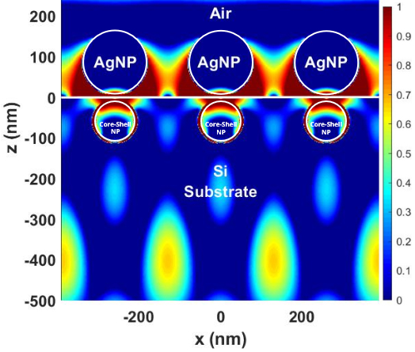
- Optical near-field enhancement image along the x-z plane for “Sandwich” configuration of 160nm AgNPs placed on top of the Si substrate and spherical core-shell NPs embedded inside the Si substrate.

- Results for Large Scale Array Implementation of Pyramidal Core-Shell NPs Embedded Within the Absorber Layer

- Optical Absorption Enhancement and Short-Circuit Current Density for Varying Pitch Sizes of Embedded Pyramidal Core-Shell NPs in array Configuration.
Table 5.6.1 shows the absorption enhancement factor (g) and short-circuit current density values obtained when the pitch or interparticle distance between nanostructures in the array was varied from 5nm to 400nm, for pyramidal core-shell NPs embedded inside the absorber layer. The pitch was measured to be the distance from the side of the base of one nanostructure to the side of the base of the adjacent nanostructure. From optical absorption enhancement factor (g) the values obtained, it can be seen that the highest g value was observed for 5nm pitch size (g = 1111.859). Furthermore, the g value can also be observed to decrease as pitch size was increased from 5nm to 400nm (g = 230.188). The maximum short-circuit current density (J_{SC}) value of 201.269 A/m² was obtained for a pitch size of 10nm, indicating highest current generation for embedded pyramidal core-shell nanoparticles in array configuration. The values for J_{SC} were observed to decrease as the pitch size was increased from 10nm (J_{SC} = 201.269 A/m²) to 400nm (J_{SC} = 77.2909 A/m²).

- Optical absorption enhancement and short circuit current density (J_{SC}) for varying pitch sizes of Embedded Pyramidal Silver-Silica Core-Shell NPs in array.

Pitch (side to side) (nm) for Embedded Pyramidal Core-Shell NP | Absorption Enhancement Factor (g) | Short-Circuit Current Density (J_{SC}) A/m²
Bare | 150 | 61.753
5 | 1111.859 | 195.782
10 | 972.896 | 201.269
20 | 894.523 | 190
40 | 776.499 | 176.061
50 | 715.301 | 167.302
60 | 656.419 | 158.705
80 | 547.389 | 142.535
100 | 456.413 | 128.322
150 | 324.621 | 101.43
200 | 297.963 | 93.329
250 | 287.875 | 89.923
300 | 258.235 | 89.923
350 | 244.315 | 79.873
400 | 230.188 | 77.290

- Optical Near-field Enhancement Analysis
Figure 5.6.2 shows the optical near-field enhancement image for the pyramidal core-shell nanoparticles in array configuration. The red regions represent a ten-fold enhancement of the electromagnetic field in the immediate vicinity of the nanoparticles. It can be observed that the electromagnetic field strength is strongest near the apex of the pyramidal nanostructures. Furthermore, bright green and yellow regions within the substrate indicate 4-fold near-field enhancement, approximately. These observations reinforce the results obtained in Table 5.6.1 and shows the superior current generation capability of embedded pyramidal core-shell nanoparticles in array configuration.

- Optical near-field enhancement image along the x-z plane for pyramidal core-shell NPs embedded inside the Si substrate.

- Results for Large Scale Array Implementation of “Sandwich” Configuration of Homogenous Nanoparticle on Top and Embedded Cubical Core-Shell NP

- Optical Absorption Enhancement and Short-Circuit Current Density for Varying Pitch Sizes of Homogenous NP and Embedded Cubical Core-Shell NP in “Sandwich” Configuration
Table 5.7.1 shows the absorption enhancement factor (g) and short-circuit current density values for the “Sandwich” configuration of Homogenous NP (placed on top of the absorber layer) and cubical core-shell NP (embedded inside the absorber layer), obtained when the pitch or interparticle distance between nanostructures in the array was varied from 5nm to 400nm. The pitch was measured to be the distance from the side of one nanostructure to the side of the adjacent nanostructure. The highest absorption enhancement factor (g) was obtained when the pitch size was 40nm (g = 1116.708). Unlike the results of the previous array configurations, the absorption enhancement factor and short-circuit current density (J_{SC}) both followed the same trend, i.e., both g and J_{SC} values increased between 5nm to 40nm pitch sizes and decreased for pitch sizes higher than 40nm. Therefore, the highest short-circuit current (J_{SC} = 292.807 A/m²) was obtained for a 40nm pitch size indicating a high rate of electron-hole pair creation and current generation.

Furthermore, from the results in Table 5.7.1, it is evident that the short-circuit current density (J_{SC} = 292.807 A/m²) and optical absorption enhancement (g = 1116.708) values obtained is the highest when compared with all other configurations discussed thus far, indicating the superiority of the “Sandwich” configuration of homogenous NP and embedded cubical core-shell NP in array towards enhancing the optoelectronic performance of thin film solar cell.

- Optical absorption enhancement and short circuit current density (J_{SC}) for varying pitch sizes of “Sandwich” configuration of Homogenous Spherical Silver NP and Embedded Cubical Silver-Silica Core-Shell NP, in array.

Pitch (side to side) (nm) for “Sandwich” Configuration of Homogenous NP on Top and Embedded Cubical Core-Shell NP | Absorption Enhancement Factor (g) | Short-Circuit Current Density (J_{SC}) A/m²
Bare | 150 | 61.7538
5 | 407.295 | 82.528
10 | 518.294 | 138.868
20 | 879.873 | 232.070
40 | 1116.70 | 292.807
50 | 1103.06 | 290.122
60 | 1043.527 | 276.771
80 | 881.851 | 243.935
100 | 723.053 | 215.547
150 | 489.596 | 180.792
200 | 445.378 | 169.823
250 | 409.599 | 158.860
300 | 364.268 | 142.678
350 | 331.648 | 125.668
400 | 301.829 | 112.930

- Optical Near-field Enhancement Analysis
Figure 5.7.2 shows the optical near-field enhancement image for the “Sandwich” configuration of homogenous NPs and embedded cubical core-shell NPs in array. The red regions represent a ten-fold enhancement of the electromagnetic field in the immediate vicinity of the nanoparticles. The near-field enhancement can be observed to take place in two steps; 1) initial enhancement due to the homogenous nanoparticles on top of the absorber layer, and 2) additional enhancement due to plasmonic coupling with the embedded core-shell nanoparticles. Here, the light scattered by the homogenous NPs on top of the substrate can be observed to couple with the large sides of the cubical core-shell NPs embedded inside the substrate. The result is the amplification of the electromagnetic fields within the substrate, as denoted by the green, yellow and orange regions that represent a 6-fold near-field enhancement inside the absorber layer. These observations cement the results obtained in Table 5.7.1 and supports the high values obtained for the optical absorption enhancement factor and short-circuit current density for the current “Sandwich” configuration in array.

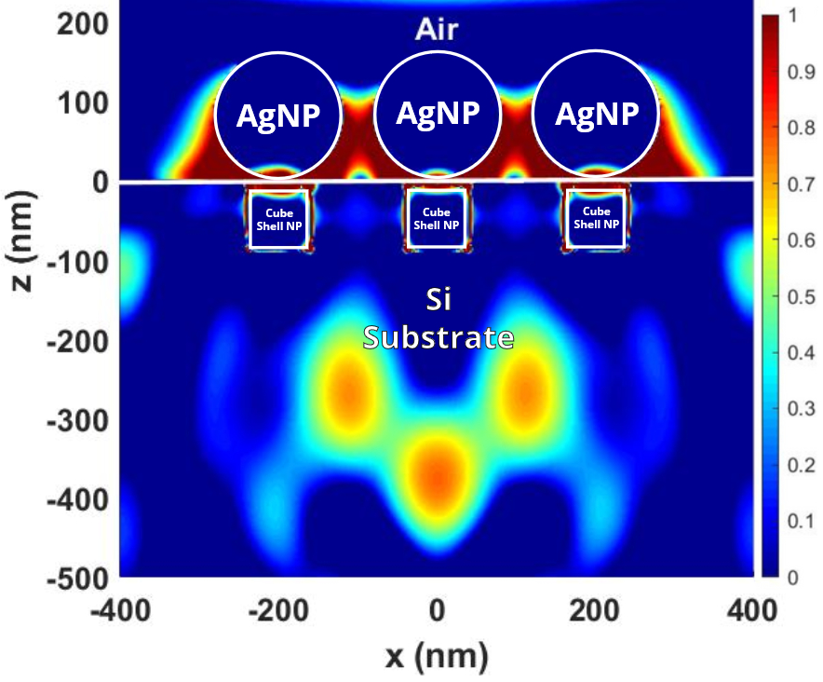
- Optical near-field enhancement image along the x-z plane for “Sandwich” configuration of 160nm AgNPs placed on top of the Si substrate and cubical core-shell NPs embedded inside the Si substrate.

- Performance Parameter Comparison Between Various Arrays of Hybrid Plasmonic Nanoparticle Array Configurations
Table 5.8 outlines all the optoelectronic performance parameters used to determine the optimal hybrid plasmonic nanoparticle configuration capable of enhancing the opto-electronic performance of thin-film solar cells. It is evident that all array configurations produced improved results when compared to single unit nanostructure configurations. Among the three large scale array configurations, the “Sandwich” configuration of homogenous NPs on top of the substrate and cube-shell NPs embedded inside the substrate, produced significantly improved results in terms of optical absorption enhancement factor (1116.708), short-circuit current density (292.807A/m²), open-circuit voltage (0.469853V), fill factor (0.7945), output power per unit area (109.30W/m²), and percentage increase in efficiency when compared to the bare substrate (470.88%). Therefore, it is apparent that the array “Sandwich” configuration of the homogenous NPs together with embedded cube-shell NPs, can be deemed as the most optimal configuration which can be employed towards increasing the opto-electronic enhancement of thin-film solar cells.

- Comparison between the presented array configurations, in terms of the optical absorption enhancement factor (g), short-circuit current density (J_{SC}), open-circuit voltage (V_{OC}), fill factor (FF), output power per unit area, and percentage increase in efficiency.

Array Configuration | Absorption Enhancement Factor (g) | Short-Circuit Current Density (J_{SC}) A/m² | Open-Circuit Voltage (V_{OC}) V | Fill Factor (FF) | Power  W/m² | Efficiency  (% increase)
Bare | 150 | 61.7538 | 0.402138 | 0.7710 | 19.15 | -
Homogenous NPs and Embedded Sphere-Shell NPs in “Sandwich” | 388.025 | 101.723 | 0.4001 | 0.7702 | 31.35 | 63.74
Embedded Pyramid-Shell NPs | 1111.859 | 201.269 | 0.4085 | 0.7734 | 63.59 | 232.14
Homogenous NPs and Embedded Cube-Shell NPs in “Sandwich” | 1116.708 | 292.807 | 0.4698 | 0.7945 | 109.30 | 470.88

CHAPTER 6
SOCIO-CULTURAL, HEALTH AND ENVIRONMENTAL CONCERNS

- Impact of the Project on Societal, Health, Safety, Legal and Cultural Issues
The continuous rise in the quantity of greenhouse gases (GHG) have led to an increase in earth’s average temperature, the rise of sea-levels and is causing global climate change. Recent erratic weather patterns observed around the world such as the increase in the frequency of droughts, floods, typhoons, hurricanes and the increase in severity of these weather phenomena if compared to the records of the past, point towards an anomaly that can be explained by global warming and climate change which can be attributed to the increase in GHG due to man-made practices. A significant source for GHGs can be attributed to the power generation plants (mainly the fossil fuel powered plants) operated around the world. According to ‘Global Climate Risk Index 2020’ report published by Germanwatch, in the period from 1998 till 2018, Bangladesh ranked seventh in the long-term climate risk index. The power generation plants are responsible for 52% of carbon dioxide (CO2) emissions of the country [46]. If emission levels from these plants are not brought down, adverse environmental, health and security issues may arise in Bangladesh. With the current rate of use of natural gas for energy generation and plans to further increase usage to meet the energy demands, natural reserves of gas are bound to be depleted by the next decade. To meet this demand, construction of new fossil fuel plants using coal (e.g., Rampal Power Station) have been proposed. Doing so will lead to irreversible damage to the environment and ecology of the area and bring about adverse health effects to the people living around the vicinity of the plants. People living near coal powered plants have shorter life expectancy with higher death rates among the populace and are more prone to respiratory disease, lung cancer, cardiovascular disease and other health problems due to the expulsion of pollutants such as fly ash, sulphur dioxide, cadmium, nickel, and lead contaminates (among others) the air and water in the vicinity of the plant [47]. While it may be true gas-fired power plants are more environmentally friendly than coal-fired power plants, due to diminishing natural reserves [15], substantial investments should be made in the renewable energy sector to mitigate the health hazards and environmental pollution created due to fossil fuels.

The production (raw materials extraction and manufacturing of the panels) and operation of solar panels during their lifetimes create lower CO2 emission in order of several magnitudes lower than fossil fuel power plants do [48-51]. There are also no harmful pollutants released into air and water during the operation of Solar PV systems, benefitting both the health of the populace and limiting the adverse environmental effects generally associated with traditional fossil fuel power plants. Second (2nd) generation or thin-film solar cells require lower amount of materials than crystalline solar cells and so thin-film solar cells are more ecologically friendly than traditional soar cells. Due to reduction of thickness of thin-film solar cells, they also tend to be elastic increasing the flexibility in the location for deployment (can lead to reduction in land requirement for deployment and more robust structure to withstand adverse environmental conditions like cyclones, etc.).

In order to tackle the problems of power generation (of Bangladesh) stated throughout the report, the government needs to follow in the steps of countries (Germany, Iceland, Kenya, Morocco, China, U.S.A. etc.) that have been successful in adopting renewable energy practices. The policies used to realize their energy goals need to be scrutinized, evaluated and possibly be modified to suit the current situation (socio-economic and political) of Bangladesh. The government’s renewable energy policy introduced in 2008 needs to be updated, better incentives need to offered to investors investing in renewable energy sector when compared to making investments in traditional energy sources. For example, according to the plan put forth in 2008 investors investing in renewable energy projects are exempted from corporate income tax for a 5-year period whereas, private power companies operating conventional power plants (coal, gas and oil) are exempted from corporate tax for a period of 10-years. Aside from policy issues another potential barrier this proposed project may face is the use of patented and copyrighted technology during the fabrication process as thin film-solar cell is a relatively new technology with new ideas constantly being brought forth and patented.

Extreme remote and rural areas in Bangladesh still have no access to electricity (5%) due to the high cost and challenges involved in connecting these remote areas to the national grid [52]. Hence, using stand-alone power systems (e.g., solar homes) or using microgrids is the only feasible solution to deliver electricity to these areas. Lack of access to electricity in remote areas of the country have impeded the development and growth in these areas and is a hurdle that needs to be overcome for Bangladesh to transition into a developing country.

Facilitating electricity in these rural areas can bring about development and growth. Access to electricity can improve the standard of living, a better quality of education, access to broader markets hence, more trade and income opportunity. It can also lead to the development of communication pathways (cellphone towers, roads, radio, etc.), thereby connecting the remote populace to the rest of the country and the rest of the world (via the internet). It also works to reduce the feeling of alienation and neglect of these people (i.e., minority tribes) living in these rural (hills and jungles) areas and make them finally feel like being accepted as a citizen with equal facilities as the vast majority of people living elsewhere in the country. This can prevent or discourage such estranged communities from indulging in terrorism and other illegal measures to express any form of dissent. Efforts should not only be made to provide electricity to these remote and rural areas via microgrids but also the possibility of using such grids to provide electricity in areas which have an unreliable electrical connection (frequent outages, faulty transmission lines) should be explored. The biggest hurdle in adopting PV solar panel technology is the high initial investment needed. The cost of these PV crystalline solar cells can be reduced substantially if thin-film solar cell technology is used. Initiatives should be taken to increase the awareness of the benefits of using PV thin-film solar cells when compared to crystalline PV cells and in the benefits of solar cells in general. Like most other developing countries, people of Bangladesh are not concerned and, in some case, not even aware of the environmental issues. Implementation of solar energy can give rise to a cultural movement and massive paradigm shift of the minds of the common people and thus can Bangladesh move towards a greener and sustainable future.

- Impact of Project on the Environment and Sustainability
The looming threat of global warming and climate change has brought in new investments and research focus on renewable energy systems in an effort to make it feasible and comparable to traditional energy resources. Many countries have invested heavily in renewable energy sources to reduce their carbon footprint and meet their carbon goal according to the Paris Climate Agreement 2016. In 2018, 26.1% (26614 TWh) of the world’s electricity production was generated from renewable energy sources and globally, the new installed capacity of renewable sources was greater than the installed capacity of traditional sources and nuclear power combined [15]. Since 2008, the price for PV solar modules have gone down by a factor of about 5 [53] while their efficiency has been improved, making PV solar cells be widely adopted globally for power generation. The majority of carbon dioxide (CO2) emissions in Bangladesh (52%) can be attributed to the power sector [46]. The need to adopt renewable energy sources for power generation is more important than ever especially for Bangladesh as most of the grid electricity in Bangladesh is generated by the use of fossil fuels (coal, diesel, furnace oil and natural gas account for 92.51% of total installed capacity of energy in Bangladesh) [13]. According to PSMP (Power System Master Plan prepared by the Government of Bangladesh) 2016 [16], proposed plans to increase the generation capacity in Bangladesh (shown in Figure 6.2.1) point to an alarming scenario where the dependence of foreign imports of fuel for power generation would increase, thereby decreasing the energy security in Bangladesh and lead to an increase in the already high carbon dioxide emission (CO2) from power sector due to the increase in fossil fuel power plants. From Figure 6.2.1, it is observed two of the five scenarios (P1 and P2) show coal to be the primary fuel source for power generation in Bangladesh therefore, for the projected scenarios shown in Figure 6.2.1, CO2 emissions are highest for scenario P1 (0.82 CO2 kg-C/kWh), due to the reliance on a high percentage of coal for fuel, and the lowest in scenario P5 (0.55 CO2 kg-C/kWh), which uses the lowest percentage of coal among the five scenarios [16]. Adopting a scenario more geared towards the use of renewable energy sources such as PV solar systems, therefore, would not only be better for the environment as PV solar systems have lower CO2 emissions, of approximately 40g CO2 eq/kWh compared to an approximate1000g CO2 eq/kWh for coal, 640g CO2 eq/kWh for natural gas-fired combustion turbine (NGCT) and 460g CO2 eq/kWh for natural gas-fired combined-cycle systems [48-51], it would also decrease the dependency on foreign imports of fuel (such as coal, natural gas) and therefore increase the energy security in Bangladesh.

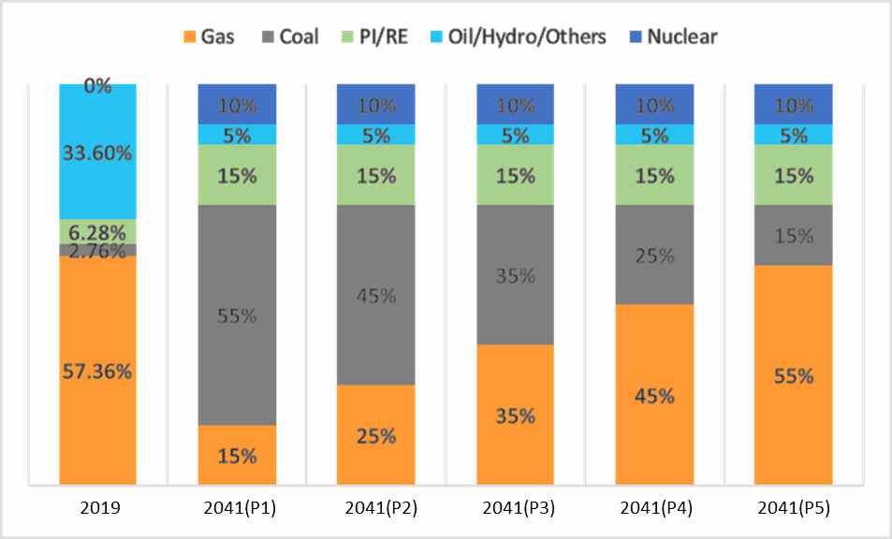
- Current (2019) and planned (2041) composition of fuel type for energy generation in Bangladesh [16].

Traditional or 1st generation PV solar cells are the predominant type of solar cells that are available in the market. Crystalline (monocrystalline and polycrystalline) Si makes up the bulk of the material used in these 1st gen cells and is the main contributor to the high price. The typical thickness of the cut wafers of 1st gen models was around 180 µm with a kerf loss (amount of material that is lost during the cutting process) on the order of 100 µm [54-56]. To find an alternative to using high quantities of Si, the 2nd generation of solar cells were developed. These are referred to as thin-film solar cells due to the thin-films (usually only a few microns thick) of materials used. Generally, thin-film solar cells are mainly classified into three types: i) Amorphous Si (a-Si) ii) Cadmium Telluride (CdTe) and iii) Copper Indium Gallium di-Selenite (CIGS). This project focuses on increasing the efficiency of a-Si thin-film solar cells. While amorphous silicon thin-film solar cells require a lower quantity of materials than crystalline silicon cells, unfortunately they are also less efficient (than crystalline cells) due to the reduction in the absorbing layer (silicon). The primary focus of this project is on enhancing the opto-electronic performance of a-Si (amorphous Silicon) thin-film solar cells by utilizing the plasmonic properties of hybrid core (metal)-shell (dielectric) NPs. Potentially higher efficiency and fewer quantity of materials used can lead to more affordable solar panels and more widespread adoption of renewable energy with significantly lower carbon emissions compared to fossil fuels.

For sustainable development of a technology, it must be ensured that the present needs for it are met while making sure that the development and use can also be supported in the future. For PV solar cells to become a major sustainable competitor in the power generation market, the materials involved in the manufacture of these cells must be abundant, affordable and have a much lower environmental impact than its traditional counterparts. One other criterion that must be met to contend against the major players (fossil fuels) in the electrical energy generation sector, is that the cost of PV power must be equal to or lower than the cost of grid electricity. While 1st generation crystalline PV cells now cost much lower than they did before, it is still expensive, that is why extensive research is being done in developing efficient thin-film solar cells (2nd generation cells) which are cheaper than crystalline Si solar modules by a factor of two [57] and require less material than crystalline Si cells. A possible major constraint in the widespread expansion of thin-film PV technology comes in the form of limited availability of the materials used in the fabrication of these cells. Tellurium (Te), Indium (In), Cadmium (Cd), Gallium (Ga) and Germanium (Ge) as these materials are the minor by-products in the purification/extraction of Copper (Cu), Lead (Pb) and Zinc (Zn). Hence, the availability of these products is directly linked to the production of the base metals [58-59]. Even with the aforementioned constraint in the availability of the materials involved in fabrication, the growth of thin-film solar cells market should be sustainable to provide Terawatts of renewable energy by the mid-21st century [58-59]. Sustainability issues due to shortage of materials can further be mitigated by developing more efficient recovery methods for the by-products produced during the extraction of base-metals, using even thinner semiconductor layers, increasing the life expectancy of each PV module and development of schemes to efficiently recycle the modules at the end of their lifecycle [58].

CHAPTER 7
ADDRESSING COMPLEX ENGINEERING PROBLEMS AND ACTIVITIES

Numerous engineering problems were found to be associated with the current project given its scope and complexity, as shown in Table 7.1.1. The most fundamental issue faced was the depth of knowledge. This was overcome by gather information regarding the state of the power sector, PV potential of Bangladesh, nanoparticle physics, plasmonic solar cell design, etc. Various analyses such as nearfield, extinction spectra, optical absorption enhancement, etc. were performed to address the depth of analysis criteria. Moreover, foreign stakeholders like Hanergy Thin Film & swift solar, and local stakeholders like Rahimafrooz & Greenfinity Energy LTD were considered as potential industry investors. The project adhered to the standard testing conditions detailed in the IEC 61646 certification for the testing of terrestrial thin-film solar cells. The current project also has an interdependence on various branches of electrical engineering and physics such as plasmonics, photonics and photovoltaics. Given the theoretical and experimental nature of the project there were no conflicting requirements.

- Complex engineering problems associated with the current project.

Problems |  | Addressing the problems
WP1 | Depth of knowledge required (WK3-WK5, WK8) | The project requires knowledge of the current state of the energy sector and the PV potential of Bangladesh, existing thin-film solar cell technologies, physics of plasmonic nanostructures, plasmonic solar cell design parameters, and PV industry standards.
WP2 | Range of conflicting requirements | No conflicting requirements.
WP3 | Depth of analysis required | Several opto-electronic analyses (extinction spectra analysis, optical absorption enhancement factor analysis, short-circuit current analysis, optical near-field analysis, etc.) were carried out to determine an optimal design.
WP4 | Familiarity of issues | The project involves fundamental concepts associated with electrical engineering (photovoltaics, photonics, plasmonics, solid state physics, etc.).
WP5 | Extent of applicable codes | IEC 61646 - STC (ASTM G-173/AM 1.5G, 300K, 1000W/m²).
WP6 | Extent of stakeholder involvement | Solar cell manufacturers like Hanergy Thin-Film, SwiftSolar, Freschfield, JA Solar, SunPower Corp., Rahimafrooz Renewable Energy LTD, Greenfinity Energy LTD, etc.
WP7 | Interdependence | Project involves interdependence between different branch of physics and electrical engineering (plasmonics, photonics and photovoltaics).

The complex engineering activities are detailed in Table 7.1.2. To gain the required knowledge, a wide range of resources were utilized like peer-reviewed conference proceedings and journal articles. A substantial monetary investment was made to procure the licenses of our simulation software. Furthermore, the nanoparticle configurations investigated included subsystems comprising core-shell NP of varying thickness, Sandwich configuration of nanoparticles, etc. From an electrical engineer's perspective, the project delves in the unfamiliar territories of plasmonics and nanoparticle physics besides building upon the existing works on thin film solar cell design. Additionally, the proposed hybrid nanoparticle systems for plasmonic solar cells is a novel design, as evident from the current groups recent successful publications, thus fulfilling the innovation criteria. Lastly, the project can be deemed eco-friendly and sustainable given the resources used. And implementation of the project will have a positive effect in terms of general health and societal development.

- Complex engineering activities associated with the current project.

Activities |  | Addressing the activities
EA1 | Range of resources | Utilized peer-reviewed journal articles, peer-reviewed conference proceedings, course content (EEE 313), online resources, and semiconductor physics text books.
EA2 | Level of interactions | Attended and presented research findings at various conferences (local and international). Published a peer-reviewed journal article and several peer-reviewed conference proceedings. Discussed and networked with peers of the field to exchange ideas and be up-to-date with the advancement in thin-film solar cell technologies.
EA3 | Innovation | The proposed hybrid nanoparticle system comprising an homogenous nanoparticle, embedded core-shell nanoparticle and “sandwich” configuration are all novel designs pushing the boundaries of current plasmonic thin-film solar cell technologies, as evident from the results obtained.
EA4 | Consequences to society / environment | The project was found to be sustainable and eco-friendly in terms of resources utilized. Studies showed adoption of the technology researched in the project will have a direct positive effect by potentially reducing carbon emissions and fossil fuel use, which can aid in the betterment of the health of the people, and help in the development of community/society as a whole.
EA5 | Familiarity | The project builds upon existing works of thin-film solar cell design but also delves into unexplored fields of plasmonics and nanoparticle physics to meet the outcomes and objectives.

CHAPTER 8
CONCLUSIONS AND FUTURE WORKS

This thesis presents an exhaustive and detailed study on the use of hybrid plasmonic core-shell nanoparticles with thin-film silicon solar cells. The data used in the study was obtained using the FDTD (finite difference time domain/ Yee’s) method as it was the most reliable, rigorous, and powerful tool to model nanoscale optical devices. The study begins by investigating the change in the opto-electronic performance of Si thin-film solar cells when modified by these hybrid core-shell nanoparticles embedded inside the absorbing layer. The results indicate that a ‘sandwich’ configuration comprising homogenous NP on top and an embedded core-shell NP showed improved results. It has been stated before that the optical properties of such hybrid nanoparticles are highly morphology dependent hence, to study the morphological properties of these core-shell nanoparticles and their influence on the optoelectronic performance of the solar cells, simulations were carried out using five differently shaped (cube, sphere, spheroid, cylinder and pyramid) core-shell nanoparticles. The optimum shell thickness of these nanoparticles was determined and was then used in different configurations (embedded core-shell nanoparticles within the absorbing substrate and a ‘sandwich’ configuration) to determine the opto-electronic performance of thin-film silicon solar cells modified with these hybrid core-shell NPs. The results obtained showed that pyramid-shaped core-shell nanoparticles had the improved performance for the configuration containing just core-shell nanoparticles embedded within the absorbing substrate and cube-shaped core-shell nanoparticles gave further improved results in the ‘sandwich’ configuration. Both optical and electrical parameters were used to reach this conclusion. The pyramid-shaped core-shell particle showed significant improvements in terms of electrical parameters and the near-field images showed higher plasmonic coupling inside the Si substrate for the embedded pyramid-shaped core-shell particle alone case. The cube-shaped core-shell nanoparticle showed improved performance in the ‘sandwich’ configuration due to a wider and stronger plasmonic coupling between the homogenous spherical nanoparticle on the top, the Si substrate, and the nanoparticle itself as witnessed in the enhanced near-field images obtained. However, these simulations were carried out using only single nanoparticles utilizing a small portion of the solar cell for the simulation region, to investigate the effect that a single hybrid particle (in different configurations) can have on the opto-electronic performance of the solar cell when compared to that of the bare silicon substrate. Practical implementation of these hybrid nanostructures would involve creating large scale arrays using these hybrid NPs as opposed to using single nanoparticles.
To that end simulations were designed and carried out using the optimal physical parameters (i.e., particle shape, size, and configuration) obtained when single nanoparticles were used, to determine the optimal pitch size (side-to-side interparticle distance) for these hybrid nanostructures when used in an array configuration. The results revealed that embedded pyramid-shaped core-shell nanoparticles showed improved performance when compared to spherical core-shell NPs in ‘sandwich’ configuration, indicating greater plasmonic coupling and light trapping for embedded triangular core-shell nanoparticles in large scale arrays. Significantly improved opto-electronic performance for these hybrid NPs used in large scale arrays was obtained using the ‘sandwich’ configuration comprising a homogenous Ag NP on top of the cell with an embedded cube-shaped core-shell particle embedded within the absorbing Si layer which showed an efficiency increase of 470.88% when compared to the bare silicon substrate as is evident by the strong plasmonic coupling and high-intensity EM field observed in the enhanced near-field image. The results of this study conclude that thin-film solar cells modified by using these hybrid nanoparticles in ‘sandwich’ configuration can potentially increase the performance of commercially available silicon-based thin-film solar cells by nearly five times. This improved performance coupled with the versatility of deployment can lead to widespread adoption of TFSC technology leading to reduced emissions, energy independence, better energy security as well as better air quality thus creating a positive impact on the health of the people as well. Future work needs to be done to investigate the effect of the performance of solar cells when different plasmonic metals and different dielectric materials are used to create these hybrid nanoparticles.
Future works will involve simulating solar cells with p-n junctions, contacts and varying doping concentrations. The effect of varying the pitch of both top and embedded nanoparticles in large scale array simulations can also be investigated to study its effect. Further research will also be conducted by investigating the dimer/trimer core-shell nanoparticle complexes, investigating the use of core-shell nanoparticles made of alloys, investigating the effect of different dielectric shell layers and their thickness towards enhancing the opto-electronic performance of thin-film solar cells. Lastly, experimental implementation of the current simulation study will need to be conducted to access the deviations between simulated and practical results.

REFERENCES

Asian Development Bank, https://www.adb.org/countries/bangladesh/economy.

USAID, “Challenges in the development of variable renewable energy in Bangladesh” SURE. June 2020.

Kannan, Nadarajah, and Divagar Vakeesan. "Solar energy for future world:-A review." Renewable and Sustainable Energy Reviews 62 (2016): 1092-1105.

Green, Martin A., et al. "Solar cell efficiency tables (version 54)." Progress in photovoltaics: research and applications 27.7 (2019): 565-575.

Catchpole, KR and, and Albert Polman. "Plasmonic solar cells." Optics express 16, no. 26 (2008): 21793-21800.

Meier, J., Vallat-Sauvain, E., Dubail, S., Kroll, U., Dubail, J., Golay, S., Feitknecht, L., Torres, P., Fay, S., Fischer, D. and Shah, A., 2001. Microcrystalline/micromorph silicon thin-film solar cells prepared by VHF-GD technique. Solar energy materials and solar cells, 66(1-4), pp.73-84.

V.E. Ferry, L.A. Sweatlock, D. Pacifici, H.A. Atwater, Nano Lett. 8 (2008) 4391.

C. Hägglund, M. Zäch, G. Petersson, B. Kasemo, Appl. Phys. Lett. 92 (2008) 053110.

Ashraf, Nahid Ibn, et al. "Use of Plasmonic Metal Core-Dielectric Shell Composite Nanoparticles Embedded within the Absorbing Layer to Enhance the Efficiency of Thin-Film Solar Cells." 2019 IEEE Region 10 Symposium (TENSYMP). IEEE, 2019.

Arefin SN, et al. "Computational study of “sandwich” configuration of plasmonic nanoparticles to enhance the optoelectronic performance of thin-film solar cells." 2020 IEEE Region 10 Symposium (TENSYMP). IEEE, 2020.

S.Underwood, P. Mulvaney, Langmuir 1994, 10, 3427

Sun, Y.; Xia, Y. Adv. Mater. 2003, 15, 695

BPDB Annual Report 2018-19; SREDA, “Renewable Energy Present Status.”

PETROBANGLA, Annual Report 2018.

BP, Statistical Review of World Energy 2019.

Government of Bangladesh, PSMP 2016; BPDB

Air quality index. https://www.iqair.com/us/bangladesh/dhaka

Mondal, Md Alam Hossain, and Manfred Denich. "Assessment of renewable energy resources potential for electricity generation in Bangladesh." Renewable and Sustainable Energy Reviews 14, no. 8 (2010): 2401-2413.

Laufer, D.; Schäfer, M. The implementation of Solar Home Systems as a poverty reduction strategy—A case study in Sri Lanka. Energy Sustain. Dev. 2011, 15, 330–336.

Mohammad, Hossain. "Achieving sustainable energy targets in Bangladesh." UN Chronicle 52, no. 3 (2013): 36-39.

Choudhury, Saniat Ahmed, and Mustafa Habib Chowdhury. "Use of plasmonic metal nanoparticles to increase the light absorption efficiency of thin-film solar cells." 2016 IEEE International Conference on Sustainable Energy Technologies (ICSET). IEEE, 2016.

Winans, Joshua D., et al. "Plasmonic effects in ultrathin amorphous silicon solar cells: performance improvements with Ag nanoparticles on the front, the back, and both." Optics express 23.3 (2015): A92-A105.

Isabella, O., et al. "Advanced light trapping scheme in decoupled front and rear textured thin-film silicon solar cells." Solar energy 162 (2018): 344-356.

C. Lee, S. Y. Bae, S. Mobasser, and H. Manohara, “A novel silicon nanotips anti reflection surface for the micro Sun sensor,” Nano Lett. 5(12), 2438–2442 (2005)

Y. J. Lee, D. S. Ruby, D. W. Peters, B. B. McKenzie, and J. W. P. Hsu, “ZnO nanostructures as efficient antireflection layers in solar cells,” Nano Lett. 8(5), 1501–1505 (2008).

D. Bouhafs, A. Moussi, A. Chikouche, and J. Ruiz, “Design and simulation of antireflection coating systems for optoelectronic devices: Application to silicon solar cells,” Sol. Energy Mater. Sol. Cells 52(1-2), 79–93 (1998).

Chen, Hsin-Chu, et al. "Enhanced efficiency for c-Si solar cell with nanopillar array via quantum dots layers." Optics express 19.105 (2011): A1141-A1147.

G. R. Lin, Y. C. Chang, E. S. Liu, H. C. Kuo, and H. S. Lin, “Low refractive index Si nanopillars on Si substrate,” Appl. Phys. Lett. 90(18), 181923 (2007).

Heidarzadeh, Hamid, et al. "Plasmon-enhanced performance of an ultrathin silicon solar cell using metal-semiconductor core-shell hemispherical nanoparticles and metallic back grating." Applied optics 55.7 (2016): 1779-1785.

Li, Junshuai, et al. "Low aspect-ratio hemispherical nanopit surface texturing for enhancing light absorption in crystalline Si thin film-based solar cells." Applied Physics Letters 98.2 (2011): 021905.

Yu, Peng, et al. "Giant optical pathlength enhancement in plasmonic thin film solar cells using core-shell nanoparticles." Journal of Physics D: Applied Physics 51.29 (2018): 295106.

Ghosh Chaudhuri, Rajib, and Santanu Paria. "Core/shell nanoparticles: classes, properties, synthesis mechanisms, characterization, and applications." Chemical reviews 112.4 (2012): 2373-2433.

Kim, Jong, et al. Methods of forming an amorphous silicon thin film. United States Patent US8076242B2. United States Patent and Trademark Office. 11 Dec. 2011.
- Arefin SN, et al. "Computational study of “sandwich” configuration of plasmonic nanoparticles to enhance the optoelectronic performance of thin-film solar cells." 2020 IEEE Region 10 Symposium (TENSYMP). IEEE, 2020.
- Schmidt, T. W., and M. J. Y. Tayebjee. "Upconversion." (2012): 533-548.
- Lumerical Solutions Inc., www.lumerical.com.
- Photovoltaic Cell IV. Characterization Theory and LabVIEW Analysis Code. Tutorial, National Instruments. 2012.
- Fill factor of PV cells. https://www.pveducation.org/pvcdrom/solar-cell-operation/fill-factor
- Fairooz F, Hasan J, Arefin SN, Islam S, Chowdhury MH. “Use of plasmonic nanoparticles made of aluminum and alloys of aluminum to enhance the optoelectronic performance of thin-film solar cells”. 2020 IEEE Region 10 Symposium (TENSYMP). IEEE, 2020.
- Sircar, R., B. Tripathi, and S. Gupta. "Design and simulation of thin-film silicon quantum well photovoltaic cell." (2011).
- L. Gonzalez, C. Noguez, J. Comput. Theor. Nanosci. 2007, 4, 231.
- C. Noguez, J. Phys. Chem. C 2007, 111, 3806.
- Choudhury, S.A. and Chowdhury, M.H., 2016, September. Optimizing the parameters of plasmonic metal nanoparticles to maximize the energy conversion efficiency of thin-film solar cells. In 2016 3rd International Conference on Electrical Engineering and Information Communication Technology (ICEEICT) (pp. 1-6). IEEE.
- Standard test conditions. www.siliconsolar.com/what-are-standard-test-conditions-stc/.
- Air Mass 1.5 ASTM G-173-03. https://www.nrel.gov/grid/solar-resource/spectra.html.
- World Bank, World Development Indicators 2015.
- Kravchenko, Julia, and H. Kim Lyerly. "The impact of coal-powered electrical plants and coal ash impoundments on the health of residential communities." North Carolina medical journal 79, no. 5 (2018): 289-300.

Hsu, David D., Patrick O’Donoughue, Vasilis Fthenakis, Garvin A. Heath, Hyung Chul Kim, Pamala Sawyer, Jun‐Ki Choi, and Damon E. Turney. "Life cycle greenhouse gas emissions of crystalline silicon photovoltaic electricity generation: systematic review and harmonization." Journal of Industrial Ecology 16 (2012): S122-S135.

Kim, Hyung Chul, Vasilis Fthenakis, Jun‐Ki Choi, and Damon E. Turney. "Life cycle greenhouse gas emissions of thin‐film photovoltaic electricity generation: Systematic review and harmonization." Journal of Industrial Ecology 16 (2012): S110-S121.

Whitaker, M., Heath, G. A., O’Donoughue, P., & Vorum, M. (2012). Life cycle greenhouse gas emissions of coal‐fired electricity generation: Systematic review and harmonization. Journal of Industrial Ecology, 16, S53-S72.
- O'Donoughue, Patrick R., Garvin A. Heath, Stacey L. Dolan, and Martin Vorum. "Life cycle greenhouse gas emissions of electricity generated from conventionally produced natural gas: systematic review and harmonization." Journal of Industrial Ecology 18, no. 1 (2014): 125-144.

Mondal, M.A.H. Economic viability of solar home systems: Case study of Bangladesh. Renew. Energy 2010,35, 1125–1129

SunShot, “Photovoltaic System Pricing Trends.”

Sarti, Dominique, and Roland Einhaus. "Silicon feedstock for the multi-crystalline photovoltaic industry." Solar energy materials and solar cells 72, no. 1-4 (2002): 27-40.

Green, Martin A. "Crystalline silicon photovoltaic cells." Advanced Materials 13, no. 12‐13 (2001): 1019-1022.

Terheiden, Barbara, et al. "Manufacturing 100‐µm‐thick silicon solar cells with efficiencies greater than 20% in a pilot production line." physica status solidi (a) 212.1 (2015): 13-24.

Fthenakis, Vasilis. "Sustainability of photovoltaics: The case for thin-film solar cells." Renewable and Sustainable Energy Reviews 13.9 (2009): 2746-2750.
- Fthenakis, Vasilis. "Sustainability metrics for extending thin-film photovoltaics to terawatt levels." MRS bulletin 37, no. 4 (2012): 425-430.

